CSSA STAGE 2 JUNIOR #11 NAME ___________________________________

Joshua Turns Northward

Multiple Choice: Circle ALL the Correct Answers!

1. Jabin:
a) had many horses and chariots b) was from Northern Canaan
c) camped by the waters of Merom d) gathered a huge army to go against Joshua

2. Joshua won the battle against Jabin by:
a) announcing that he was coming b) attacking him by surprise
c) setting fire to the forest near by d) trusting in God

3. After the victory over Jabin’s army, Joshua:
a) was to divide the land among the tribes b) made a great feast
c) killed the people from the cities who had joined Jabin’s army d) put Jabin in prison

4. How was Joshua to divide the land?
a) the biggest tribe got the most b) he let each tribe pick their own
c) by casting lots d) the Levites told him how to divide it

Short Answer

5. About how many years of war did it take for Joshua to conquer the land? __________________

6. What did God tell Joshua to encourage him about fighting Jabin’s army? __________________

____________________________________________________________________________

7. What land had the tribes of Reuben, Gad and the half-tribe of Manasseh asked for? _________

____________________________________________________________________________

8. How many tribes received portions of land in Canaan? ________________________________

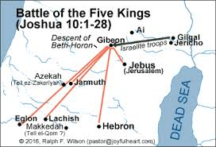
9. What were the Levites given instead of portions of land?

_____________________________________________

_____________________________________________

10. What were the tribes supposed to do after they were given their portion of land?

_____________________________________________

_____________________________________________

True or False
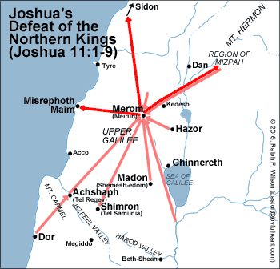
_____ 11. Joshua first conquered the southern and center parts of Canaan.

_____ 12. The Israelites took Jabin’s chariots and horses to use in future battles.

_____ 13. The priesthood of Yahweh was the Levites’ inheritance.

_____ 14. Caleb was Joshua’s brother.

_____ 15. The tribes were to keep their land free from Canaanites.

Fill in the Blanks

16. Jabin was king of ___________________.

17. Israel was to remember that ______________________ had given them the victory over their enemies.

18. The Levites were to dwell among the people and _____________________ them God’s

__________________ and __________________.

19. Caleb was given _______________________ as an inheritance.
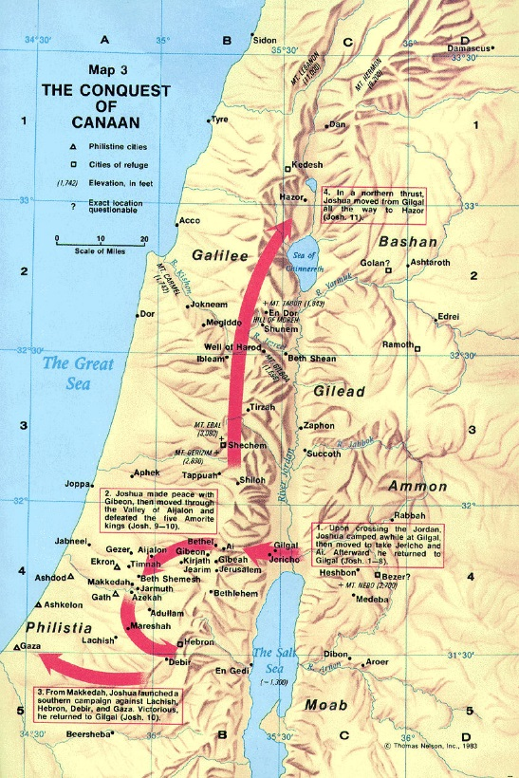
Thought Question

20. Why do you think Joshua was so successful in conquering the land?

___________________________________________

___________________________________________

___________________________________________

___________________________________________

___________________________________________

___________________________________________

___________________________________________

___________________________________________

___________________________________________

___________________________________________

