CSSA STAGE 2 JUNIOR #12 NAME ___________________________________

Joshua Dies

Multiple Choice: Circle ALL the Correct Answers!

1. Moses and Joshua:
a) read God’s word every day b) never sinned
c) gave a message to the Israelites before they died d) died at 120 years old

2. God wanted Israel to:
a) kill the Canaanites b) marry the Canaanites
c) read His word d) serve other gods

3. At Shechem, Israel promised to:
a) serve Yahweh b) serve other gods
c) build a house for God d) be baptized

4. In Joshua’s last message to Israel, he reminded them how:
a) God took Abraham out of idolatrous Ur to worship Him
b) God kept his promise
c) God saved his people from slavery in Egypt
d) God gave them this lovely, fruitful land

Short Answer

5. Why wasn’t Israel supposed to make any agreement with the Canaanites? ________________

____________________________________________________________________________

6. What did the Israelites have to do to keep themselves separate from the Canaanites so they would continue to receive God’s blessing?

____________________________________________________________________________

____________________________________________________________________________
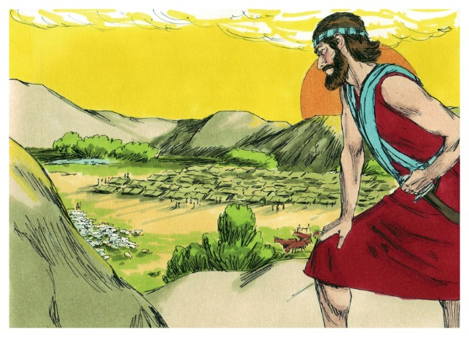
7. At Shechem, what did Israel promise to do? ________

___________________________________________

___________________________________________

8. What is idolatry? _____________________________

___________________________________________

___________________________________________

True or False
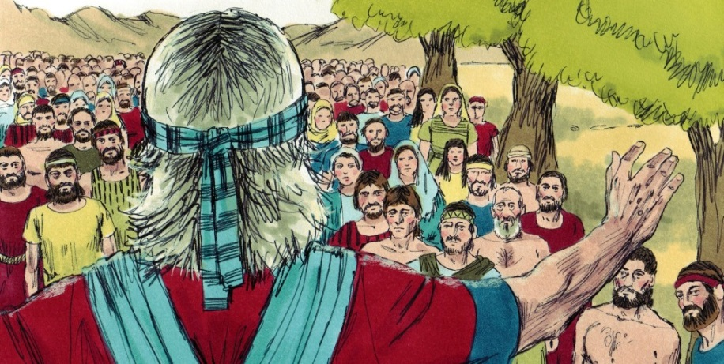
_____ 9. Joshua was like Moses, he never grew old and feeble.

_____ 10. In his last message, Joshua reminded the Israelites how thankful they should be for all that God had given them.

_____ 11. Joshua was buried on Mt Nebo.

_____ 12. At Shechem, Joshua set a stone up under a bridge to remind Israel of their promise to serve Yahweh.

Fill in the Blanks

13. Joshua gathered all the tribes of Israel and their leaders to ___________________ to hear his message.

14. “Choose you this day whom ye will ______________________ but as for me and my house,

we will serve ________________.”

15. Obedience would bring blessings and ______________________ but disobedience would

make God ______________ and He would __________________ them.

16. Idolatry is not just _____________________ down to a statue or image.

17. Idolatry is _______________________ anything more than God.

Thought Questions

18. Name three things we can do to show God we wish to serve him?

- _________________________________________________________________________

- _________________________________________________________________________

- _________________________________________________________________________

19. Name three things we shouldn’t do that could make us idolaters.

- _________________________________________________________________________

- _________________________________________________________________________

- _________________________________________________________________________
