CSSA STAGE 2 JUNIOR #13 NAME ___________________________________

Deborah and Barak

Multiple Choice: Circle ALL the Correct Answers!

1. After Joshua died Israel served Yahweh:
a) for 80 more years b) for 40 more years
c) while the leaders Joshua picked lived d) until Passover

2. During the lifetime of each judge:
a) Israel was wicked b) Israel served God
c) God delivered them from their enemies d) they celebrated a feast

3. Sisera:
a) troubled Israel for 20 years b) was an Egyptian
c) was killed by Jael d) was friends with Heber

4. Before Barak fought Sisera he:
a) wanted Deborah to go with him b) gathered 10,000 Israelites
c) fasted all night d) had a vision

Short Answer

5. When Israel departed from God, what did God do in return? ____________________________

____________________________________________________________________________

6. What is the pattern of Israel’s behavior?

S_____________________________________ S___________________________________

S_____________________________________ S___________________________________

7. When the Canaanites treated Israel cruelly, they cried to God to save them. What did God do to deliver them?
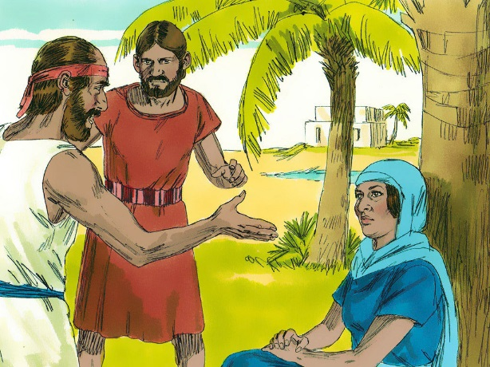
_____________________________________________

_____________________________________________

8. Why didn’t God drive the foreigners from the surrounding nations out of the land of Israel?

_____________________________________________

_____________________________________________

9. Why couldn’t Sisera use his chariots?_______________

____________________________________________________________________________

True or False
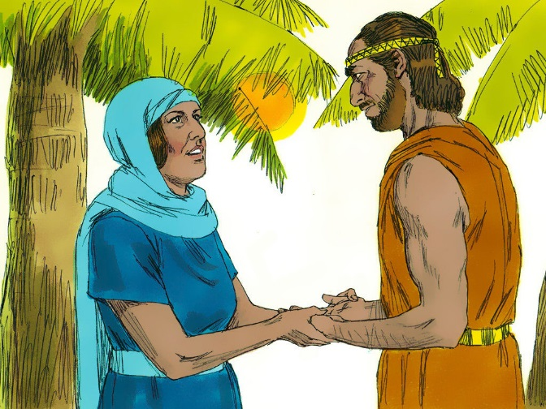
_____ 10. The Israelites turned from God and worshipped Baal and Ashtaroth.

_____ 11. The Israelites still sinned even when God sent a judge.

_____ 12. Sisera was captain of the Canaanite army.

_____ 13. Deborah was a prophetess.

_____ 14. Israel marched to Mt Sinai to meet Sisera.

Fill in the Blanks

15. “…every man did that which was _________________ in his own ______________”.

16. Sisera had ___________________ hundred chariots of iron.

17. It was revealed to Deborah that a __________________ was to lead the Israelites to victory over Sisera.

18. After the victory over Sisera the land had rest for ______________ years.

19. Using a _______________ ___________ and a _____________________ Jael killed Sisera.

Thought Questions

20. What were the people doing during the times of the judges that people today also do which causes them to behave so wickedly?

___________________________________________________________________________

___________________________________________________________________________

21. What should we be doing instead?

___________________________________________________________________________

___________________________________________________________________________

