CSSA STAGE 2 JUNIOR #14 NAME ___________________________________

Gideon and the Midianites

Multiple Choice: Circle ALL the Correct Answers!

1. The Midianites were:
a) a rock formation b) a warlike people
c) destroying Israel’s food and animals d) scaring the Israelites, forcing them to hide

2. Gideon:
a) was a faithful judge b) was brought up in a home of idolaters
c) saw and spoke with an angel d) was killed in the battle with the Midianites

3. Gideon prepared an offering for the angel and:
a) they ate it together b) vultures ate it
c) fire burned it up d) it rained

4. God chose three hundred men because:
a) the Midianite army was so small b) God wanted the Israelites to depend on him
c) they drank water without spilling d) that was the magic number

5. When Gideon fought the Midianites:
a) the sun was up b) Gideon was outnumbered
c) the Midianites killed each other d) Gideon won because he trusted in God

Short Answer

6. Why are the Israelites suffering after forty years of peace? _____________________________

____________________________________________________________________________

7. What was Gideon doing when the angel said to him, “Yahweh is with thee, thou mighty man of valor”?
____________________________________________________________________________

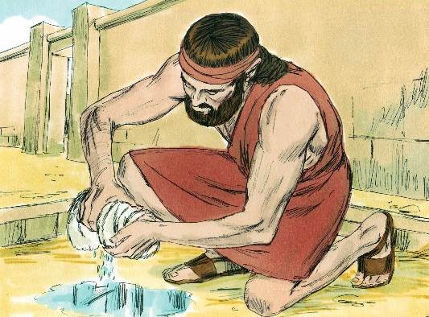
8. What two signs did Gideon ask God to show with the fleece?

- ________________________________________________

- ________________________________________________

9. Why did God let Gideon only take 300 men to fight the huge Midianite army?
___________________________________________________

___________________________________________________

10. When Gideon went with his servant to spy on the Midianites what was the dream he heard?

____________________________________________________________________________

True or False
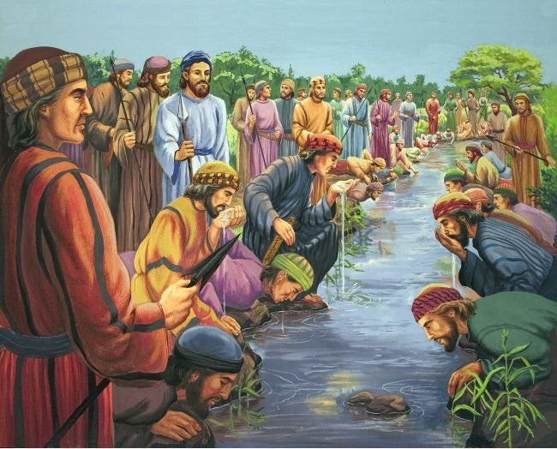
_____ 11. Gideon could have had an army of 32,000 men but God said that was too many.

_____ 12. Gideon sent all the left-handed men home.

_____ 13. Only 300 men drank water carefully so that the enemy couldn’t surprise them.

_____ 14. Gideon’s father was a worshipper of Baal.

_____ 15. An Israelite soldier said, “this is nothing but the sword of Gideon…for unto his hand hath God delivered Midian and all the host”.

Fill in the Blanks

16. God would give Israel the victory and He did not want them to say, “mine own _____________

hath ______________ me.”

17. Gideon said, “Whosoever is fearful and _______________, let him return and _____________ early.”

18. Gideon was _____________________ by a conversation he overheard in the camp of Midian.

19. At a signal from Gideon, his men blew the ________________, broke the ________________

held up the ___________________ and gave a great _________________.

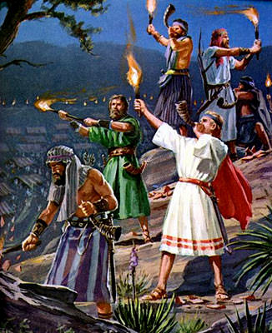
Thought Question

20. What lessons can we learn from Gideon’s example?

___________________________________________

___________________________________________

___________________________________________

___________________________________________

___________________________________________

___________________________________________

___________________________________________

___________________________________________

___________________________________________

___________________________________________

