CSSA STAGE 2 JUNIOR #15 NAME ___________________________________

Samson

Multiple Choice: Circle ALL the Correct Answers!

1. The Philistines:
a) were a powerful, warlike people b) had been conquered by Israel
c) lived along the southern seacoast of Canaan d) had five main cities

2. A Nazarite was someone who:
a) spent their time in service to God b) didn’t drink wine
c) didn’t cut their hair d) didn’t eat anything unclean

3. The Philistines:
a) put out Samson’s eyes b) wanted Samson to be part of their army
c) worshipped Dagon d) paid Delilah to find Samson’s secret for strength

4. Samson asked God to:
a) let him die with the Philistines b) remember and strengthen him
c) help him escape from prison d) make him see again

Short Answer

5. What couldn’t the Israelites make while the Philistines oppressed them and why? ___________

____________________________________________________________________________

6. Who told Manoah’s wife she would have a special son? ________________________________

7. What special ability did Samson have? _____________________________________________

Where did it come from? ________________________________________________________
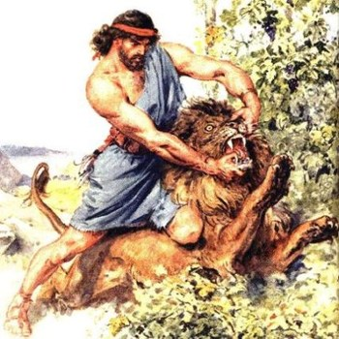
8. What was Samson’s long hair a sign of? ___________

___________________________________________

___________________________________________

9. Why did the Philistines gather in the temple of Dagon to offer a great sacrifice?

___________________________________________

___________________________________________

___________________________________________

___________________________________________

___________________________________________

True or False

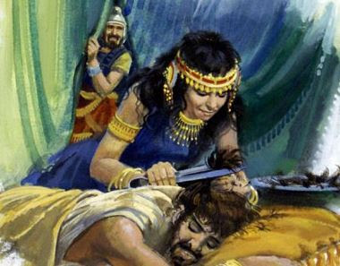
_____ 10. For 70 years Israel suffered under the Philistines.

_____ 11. Manoah was Samson’s mother.

_____ 12. Samson made regular trips into Philistine country.

_____ 13. Samson was put to work grinding corn in prison.

_____ 14. The Philistines thought Dagon had given Samson into their hands.

Fill in the Blanks

15. Samson would begin to ______________ Israel out of the hand of the __________________.

16. Once Samson pulled down and carried the _______________ of the city of ______________ to the top of the hill.

17. Samson fell in love with a Philistine woman named _____________________.

18. Dagon was the _____________________ god.

19. We should learn from Samson’s life that God’s ______________ must be ________________

and we must keep ___________________ from the world.

Thought Questions

20. What really made Samson lose his great strength? __________________________________

___________________________________________________________________________

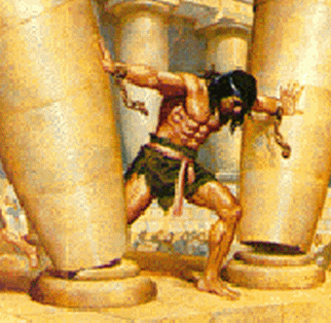
21. What lessons can we learn from Samson about marriage to someone who is not in the Truth?

___________________________________________

___________________________________________

___________________________________________

___________________________________________

___________________________________________

___________________________________________

___________________________________________

___________________________________________

