CSSA STAGE 2 JUNIOR #6 NAME ___________________________________

Two Men in Jericho

Multiple Choice: Circle ALL the Correct Answers!

1. Jericho was enclosed by:
a) two thick walls b) a tall fence c) walls 30 feet tall d) thick trees

2. Joshua sent spies into Jericho to:
a) find out about the city b) see how they built their homes
c) visit with the people inside d) find out about the people who lived there

3. Rahab knew:
a) how God delivered Israel from Egypt b) God would give the Israelites Jericho
c) the King of Jericho was looking for the spies d) the Israelites were camped outside Jericho

4. Rahab helped the spies escape by:
a) hiding them on her rooftop b) telling them to hide in the mountains for 3 days
c) letting them down the wall by a cord d) telling them to go straight back to their camp

5. Rahab was:
a) a Gentile b) an ancestor of Jesus Christ
c) very faithful d) a believer and put her trust in God

Short Answer

6. Where did Rahab hide the spies? _________________________________________________

____________________________________________________________________________

7. In return for Rahab’s kindness, what did she ask the spies? _____________________________

____________________________________________________________________________

____________________________________________________________________________

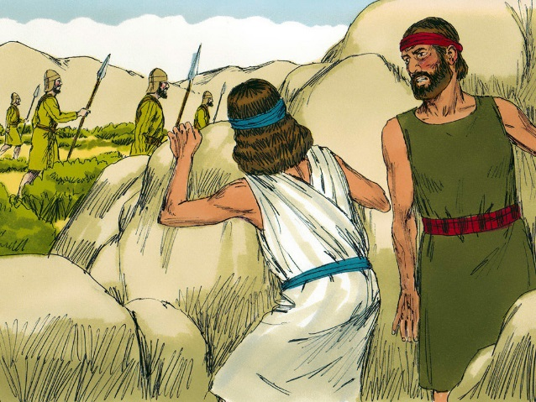
8. What did Rahab have to do in order for her family to be saved?
_____________________________________________

_____________________________________________

_____________________________________________

9. How can we become related to Jesus Christ? _________

_____________________________________________

_____________________________________________

True or False

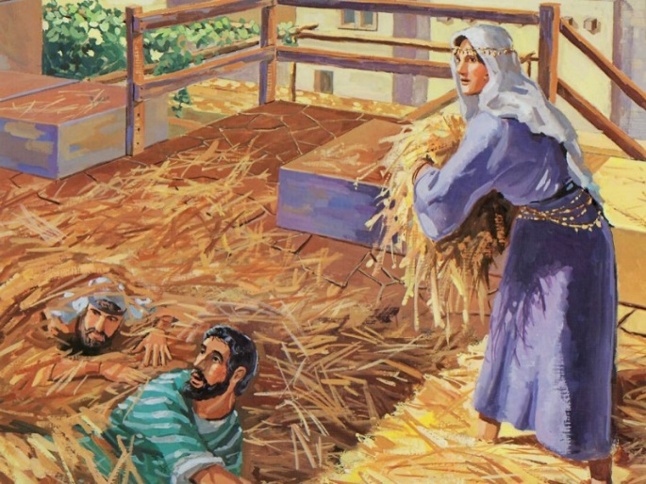
_____ 10. Jericho was the first city to be taken by the children of Israel in the Promised Land.

_____ 11. Joshua sent twelve men to spy out Jericho.

_____ 12. The people of Jericho were not afraid of the Israelites.

_____ 13. Rahab’s house was built on the top of the walls of Jericho.

_____ 14. Rahab later married Salmon of the tribe of Judah.

Fill in the Blanks

15. The spies entered ________________ and were given shelter by a woman named

_______________.

16. Jericho had two walls around it. The outer wall was __________ feet thick and the inner wall

was ___________ feet thick.

17. Rahab told the king’s _________________ that the spies left when it was _______________

at the time for shutting the _________________.

18. “For ______________________ your God, He is God in _________________ above and in

___________________ beneath.”

19. Rahab is a wonderful __________________ for us. If we _________________ and

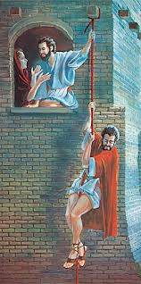
___________________ God’s word, we will also be rewarded like

__________________.

Thought Questions

20. How long before the spies came to Jericho after Israel had crossed the Red Sea?

_______________________________________________________

21. What lessons can we learn from this story? ____________________

_______________________________________________________

_______________________________________________________

_______________________________________________________

_______________________________________________________

_______________________________________________________

