CSSA STAGE 2 JUNIOR #7 NAME ___________________________________

Israel Crosses Jordan

Multiple Choice: Circle ALL the Correct Answers!

1. The Jordan River:
a) was a small stream b) was in full flood
c) connects two seas d) was low

2. Twelve men took twelve stones:
a) from the midst of the Jordan b) to set up a memorial
c) to Jericho d) to Gilgal

3. Twelve more stones were placed in:
a) the ark b) the Jordan
c) where the priests stood in the Jordan d) the Tabernacle

4. Jesus and Joshua are alike in these ways:
a) their names have the same meaning b) they both saved people
c) they were both leading people into the promised land d) they lived at the same time

5. The first place the Israelites camped after crossing the Jordan River was:
a) Jericho b) Jerusalem c) Gilgal d) Bethel

Short Answer

6. What did the people have to do before they crossed the Jordan River? ____________________

____________________________________________________________________________

7. Which Psalm does this lesson refer to? _____________________________________________

8. What did Joshua say had to be built in the river and on the other side? ____________________

_____________________________________________
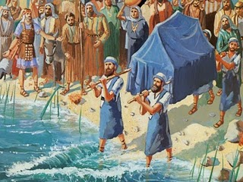
_____________________________________________

9. Why did God have the Israelites build these memorials?

_____________________________________________

_____________________________________________

10. Who were the first people to walk into the Jordan and the last ones to walk out of the river?

_____________________________________________

_____________________________________________

True or False

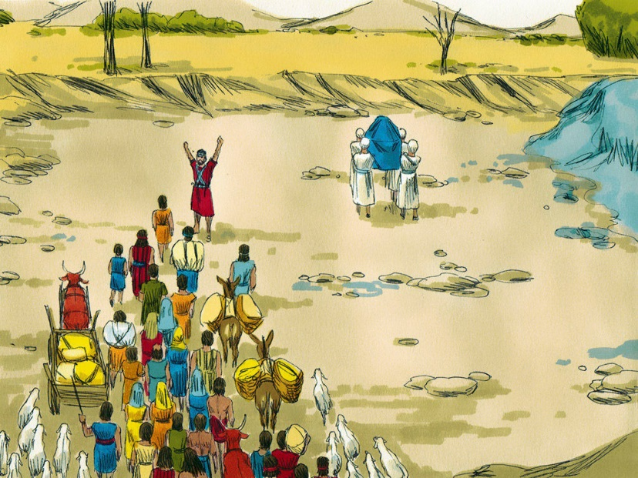
_____ 11. The ark was covered by a blue cloth.

_____ 12. The priest walked all the way across the Jordan River without stopping.

_____ 13. Twelve men caught 12 fish and ate them on the other side of the Jordan.

_____ 14. A second memorial of 12 stones was placed in the middle of the Jordan.

_____ 15. God doesn’t like us to ask questions about our worship of Him.

Fill in the Blanks

16. Shittim was on the ________________ side of the Jordan

17. When the feet of the ________________ carrying the __________ touched the Jordan, it

stopped ____________________.

18. Joshua means _________________ __________________

19. Jesus is the Greek form of ______________________.

Thought Questions
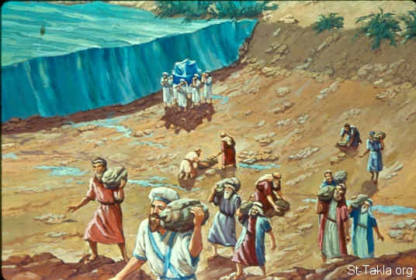
20. Why do you think the ark carried by the priests went across the Jordan first?

____________________________________________

____________________________________________

____________________________________________

____________________________________________

21. The people followed 2,000 cubits behind the ark. What do we hope will happen 2,000 years after Jesus’ birth?

___________________________________________________________________________

___________________________________________________________________________

___________________________________________________________________________

