CSSA STAGE 2 JUNIOR #8 NAME ___________________________________

Jericho

Multiple Choice: Circle ALL the Correct Answers!

1. An angel appeared to Joshua to:
a) strengthen him b) tell him God had given him Jericho
c) tell him it would be a victory gained by faith d) say he was the captain of Yahweh’s host

2. The people of Jericho:
a) stayed in the city b) were not too worried because of their strong wall
c) couldn’t see what Israel was doing d) were puzzled Israel marched around their city

3. What would happen if the Israelites took things from Jericho for themselves?
a) they would have to share them
b) a curse would be brought on the camp of Israel
c) they would have to give them to Rahab
d) what they took would disappear

4. Some lessons God wanted the Israelites to learn from Jericho’s destruction were:
a) to be faithful b) they were strong enough to take a big city
c) the victory was God’s d) to be obedient

Short Answer

5. Where did Israel camp before taking Jericho? _______________________________________

____________________________________________________________________________

6. Now that the people were in the land, what were they supposed to eat? ___________________

____________________________________________________________________________

7. In what order did the Israelites march around the city? _________________________________

_____________________________________________
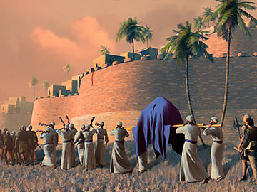
_____________________________________________

8. How many times did the Israelites march around the city

the first six days? ________ the 7th day? _________

9. What was supposed to happen to all the silver, gold, brass and iron from Jericho?

_____________________________________________

_____________________________________________

True or False

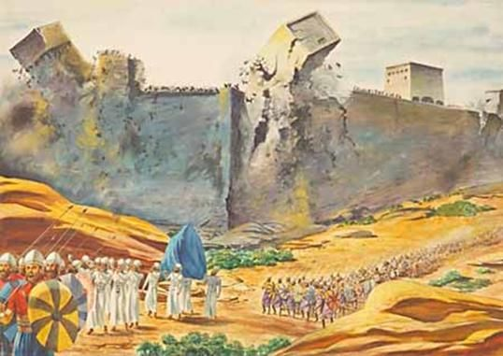
_____ 10. The manna stopped now that the people were in the Promised Land.

_____ 11. The gates of Jericho stayed shut day and night while the Israelites were camped outside the city.

_____ 12. It was ok if the people whispered during the first 6 days of marching.

_____ 13. God told Joshua to destroy all the people and animals in the city except Rahab and her family.

_____ 14. The loud noise from the people shouting is what made the walls of Jericho fall down.

Fill in the Blanks

15. “all the inhabitants of the land ________________ because of you.”

16. Israel only had to wait for God’s ________________ and faithfully ______________ His

commands in order to gain the ________________________.

17. “Shout for _________________ hath given you the city.”

18. God caused the walls to fall down but the people had to ______________________ and

___________________ first.
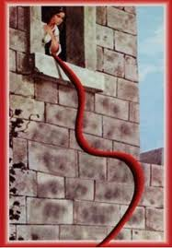
19. “Without _________________ it is impossible to please God.”

Thought Question

20. How can we get great faith like Rahab had? ________

____________________________________________

____________________________________________

____________________________________________

____________________________________________

____________________________________________

____________________________________________

