CSSA STAGE 2 JUNIOR #9 NAME ___________________________________

Attack on Ai

Multiple Choice: Circle ALL the Correct Answers!

1. Ai was:
a) the next city after Jericho that Israel was to destroy b) bigger than Jericho
c) on the main route into the Land of Promise d) destroyed by Israel’s first attack

2. In the first battle with Ai:
a) 36 Israelites died b) the people of Ai melted in fear of Israel
c) the Israelites were beaten d) Israel only sent part of their army

3. Achan was:
a) from the tribe of Judah b) stoned to death
c) guilty of taking something from Jericho d) forgiven and set free

4. In the second battle with Ai, Joshua:
a) used 30,000 men b) ambushed the men of Ai
c) burned the city d) saved the cattle

5. Lessons we can learn from the mistakes of Achan are:
a) our mistakes can hurt others b) God means every word He says
c) we can be greedy but don’t get caught d) if you admit your sin you are not punished

Short Answer

6. How far was Ai from Jericho? ____________________________________________________

7. Why was Israel beaten the first time they attacked Ai? _________________________________

____________________________________________________________________________

8. What did Joshua do when he was distressed after the defeat at Ai? ______________________

____________________________________________________________________________
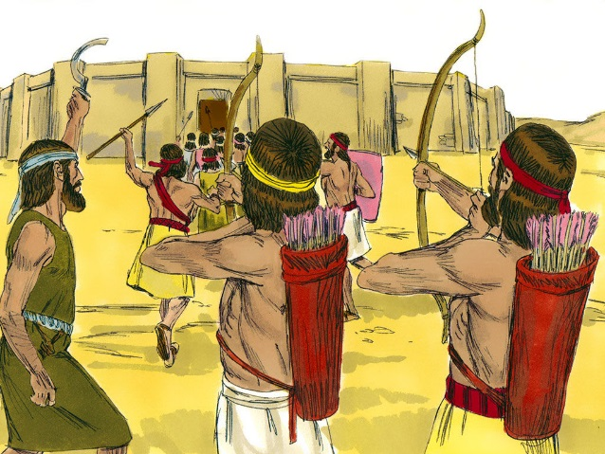
9. Name two ways Achan’s sin affected others.

- __________________________________________

- __________________________________________

10. Which two commandments did Achan break?

- __________________________________________

- __________________________________________

True or False

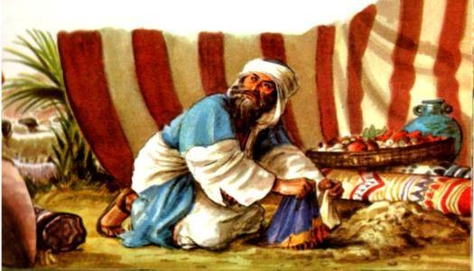
_____ 11. Achan said he didn’t take anything from Jericho.

_____ 12. It happened by chance that Achan was revealed as the sinner.

_____ 13. The stuff Achan stole belonged to God.

_____ 14. Achan and those who helped him were hanged.

_____ 15. The Israelites were allowed to keep the cattle and goods from Ai for themselves.

Fill in the Blanks

16. God said the wicked and idolatrous people of Canaan must be utterly ___________________.

17. Ai was a small town so Joshua only sent about two or three ___________________ men.

18. “Achan” means _________________________.

19. Achan _______________ a Babylonish garment, silver and gold, coveted them and

________________ them.

20. Half the tribes stood on Mt ________________ and half the tribes stood on Mt ___________ while Joshua read the blessings and cursings.

Thought Questions
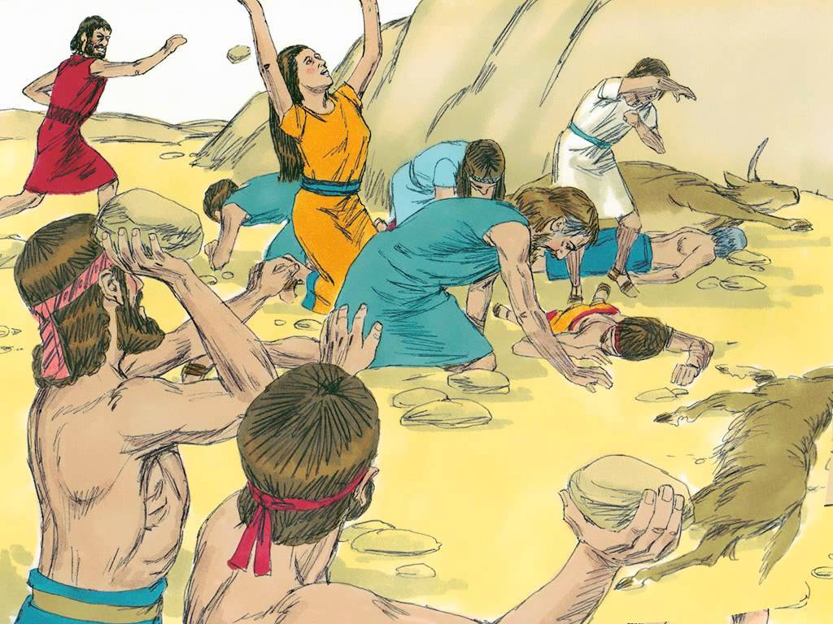
21. How do you think the lot system worked? __________

___________________________________________

___________________________________________

___________________________________________

___________________________________________

___________________________________________

___________________________________________

22. What effect do you think Israel’s defeat at Ai had on the rest of the Canaanites in the area?

___________________________________________________________________________

___________________________________________________________________________

___________________________________________________________________________

