CSSA STAGE 2 JUNIOR #16 NAME ___________________________________

Ruth

Multiple Choice: Circle ALL the Correct Answers!

1. Ruth was:
a) the great-grandmother of kind David b) a Moabite
c) determined to go with Naomi back to Judah d) a foreigner who never married

2. Naomi was:
a) married to Elimelech b) rich
c) the mother-in-law of Ruth d) a Moabite

3. Boaz was:
a) a relative of Elimelech b) a wicked wealthy farmer
c) married to Ruth d) the father of Obed

4. God said:
a) Intreat me not to leave thee or return from following after thee
b) if a man died without children his brother/next of kin must marry the widow to bear children
c) Boaz could not marry Ruth because she was a Moabite by birth
d) the reapers had to leave some food for the poor

Short Answer

5. Why did Elimelech and his family leave Bethlehem? __________________________________

____________________________________________________________________________

6. What happened to Elimelech and his sons in the land of Moab? _________________________

7. Who stayed with Naomi when she returned to Israel? Why?_____________________________

____________________________________________________________________________

8. Who told Ruth to work in the field of Boaz? ____________
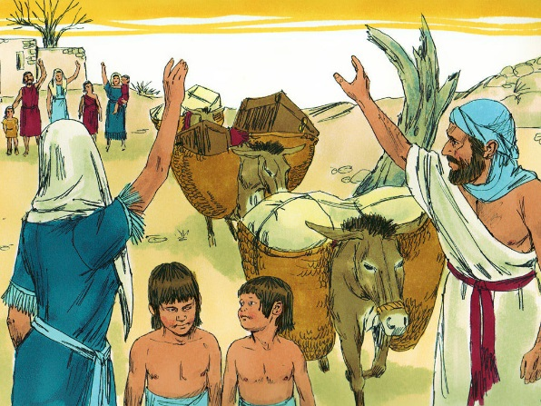
Why Boaz? _____________________________________

_______________________________________________

9. What happened the first day Ruth worked in Boaz’s field?

_______________________________________________

_______________________________________________

_______________________________________________

_______________________________________________

True or False
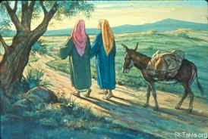
_____ 10. Ruth lived during the times of the judges.

_____ 11. Ruth married Elimelech.

_____ 12. Jesus descended from the family of Ruth and Boaz.

_____ 13. Naomi tried to get Ruth and Orpah to return to their own families.

_____ 14. Ruth returned with Naomi to Israel because she felt sorry for her.

Fill in the Blanks

15. When Naomi heard that the ______________ had ended in her own country she decided to

__________________ to it.

16. Ruth refused to _______________ Naomi and pleaded to be allowed to go with her.

17. To glean means to _____________________ corn or barley that the reapers left.

18. The blessings of the God of Israel had rested on ______________ and directed her steps to

the field of ___________________.

Thought Questions

19. Why do you think Elimelech’s nearest relative didn’t want to marry Ruth? _________________

___________________________________________________________________________

___________________________________________________________________________
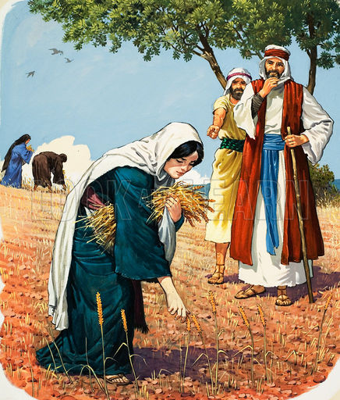
20. Name one lesson we can learn from each of Naomi, Ruth and Boaz?

Naomi _______________________________________

_____________________________________________

_____________________________________________

Ruth _________________________________________

_____________________________________________

_____________________________________________

Boaz ________________________________________

_____________________________________________

_____________________________________________

