CSSA STAGE 2 JUNIOR #17 NAME ___________________________________

Samuel

Multiple Choice: Circle ALL the Correct Answers!

1. Hannah was unhappy because:
a) Elkanah didn’t love her b) she had no children
c) she was sick d) she wanted to go home

2. Samuel:
a) grew up to be a very faithful man b) went to live with Eli in the Tabernacle as a boy
c) was spoken to by God d) was a prophet

3. Eli:
a) taught Samuel the things of God b) told Hannah she would have a son
c) died of cancer d) had two wicked sons

4. Hophni and Phinehas:
a) tried to serve God b) took the Ark into battle
c) were Samuel’s brothers d) caused the people to sin

Short Answer

5. Why did God decide to replace Hophni and Phinehas with a new priest? __________________

____________________________________________________________________________

6. Why did Hannah and Elkanah go to Shiloh each year? ________________________________

____________________________________________________________________________

7. What did Hannah promise to do if God gave her a son?________________________________

____________________________________________________________________________

8. One night God spoke to Samuel as he lay sleeping. What did God tell Samuel? _____________

_______________________________________________
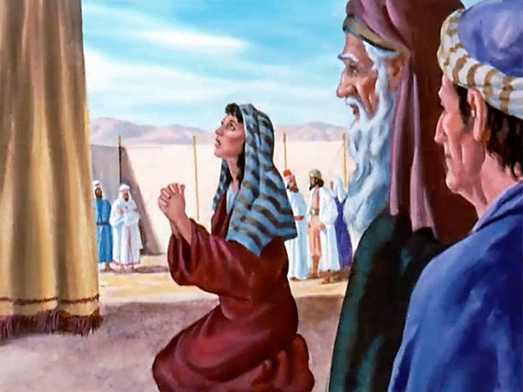
_______________________________________________

9. What happened to Eli when he heard about his sons’ death and the capture of the Ark?

_______________________________________________

_______________________________________________

_______________________________________________

_______________________________________________

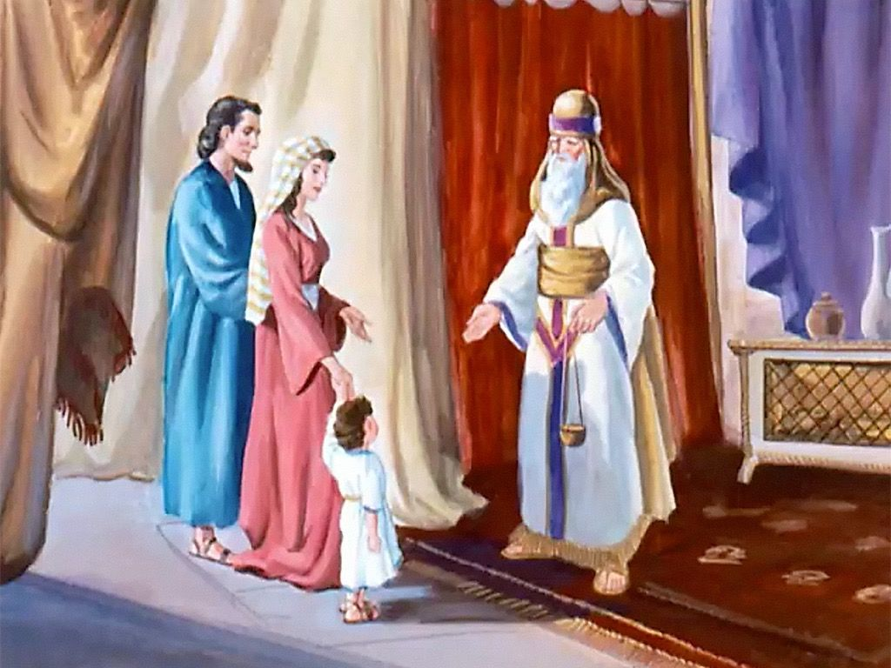
True or False

_____ 10. Eli was one of Israel’s high priests.

_____ 11. Samuel was a Nazarite.

_____ 12. Each year Hannah brought Samuel new shoes.

_____ 13. Eli died when he was 98 years old.

_____ 14. The Ark was captured by the
Amalekites.

Fill in the Blanks

15. Eli had two wicked sons, __________________ and ______________________.

16. The name “Samuel” means _______________ of _____________.

17. _____________________ and ____________________ were Samuel’s mother and father.

18. _____________________ became the new leader and prophet in Israel after Eli died.

19. The _____________________ tells us how we can please God.

Thought Questions

20. Why do you think Eli’s sons were so wicked? _______________________________________

___________________________________________________________________________

___________________________________________________________________________

21. Name one lesson we can learn from each of Hannah, Samuel and Eli?

Hannah ______________________________________
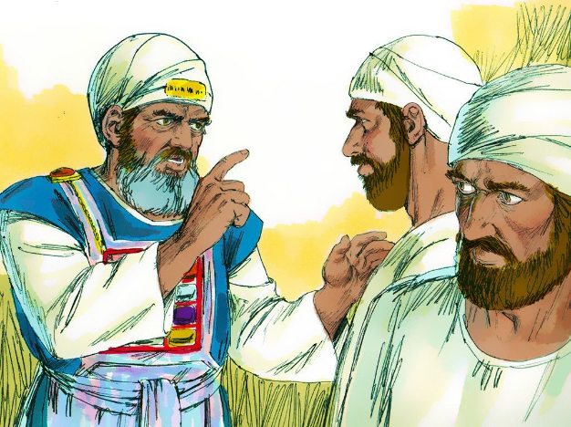
_____________________________________________

_____________________________________________

Samuel ______________________________________

_____________________________________________

_____________________________________________

Eli __________________________________________

_____________________________________________

_____________________________________________

