CSSA STAGE 2 JUNIOR #19 NAME ___________________________________

God Rejects Saul

Multiple Choice: Circle ALL the Correct Answers!

1. The story of King Saul occurs in the book of:
a) Deuteronomy b) Judges c) Ruth d) 1 Samuel

2. When Saul went to battle against the Philistines, he made the following mistakes:
a) didn’t wait for Samuel to offer the sacrifices b) became afraid and lacked faith
c) didn’t realize his army was really God’s army d) tried to kill Samuel

3. When Saul went to battle against the Amalekites, Saul disobeyed God by?
a) killing Agag b) keeping the best animals alive
c) refusing to fight the Amalekites d) marrying Agag’s wife

4. To obey is better than sacrifice means:
a) God prefers a true and honest heart rather than acts of obedience from a rebellious heart
b) God must be obeyed completely
c) we only have to obey God when we think it is important
d) it is more important to have the right attitude than to go through the motions of right living

Short Answer

5. Who was Saul going to fight at Gilgal? _____________________________________________

____________________________________________________________________________

6. Why did Saul offer the sacrifice at Gilgal in place Samuel?______________________________

____________________________________________________________________________

7. Why did God tell Saul to completely destroy the Amalekites?____________________________

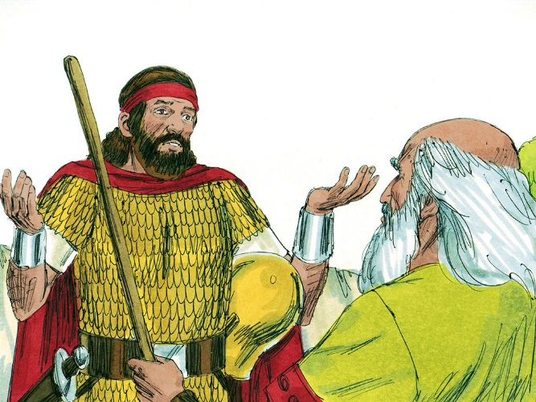
____________________________________________

____________________________________________

8. How did Saul disobey God’s commands regarding the Amalekites?
____________________________________________

____________________________________________

9. What was Saul’s punishment for his disobedience?

____________________________________________

____________________________________________

True or False

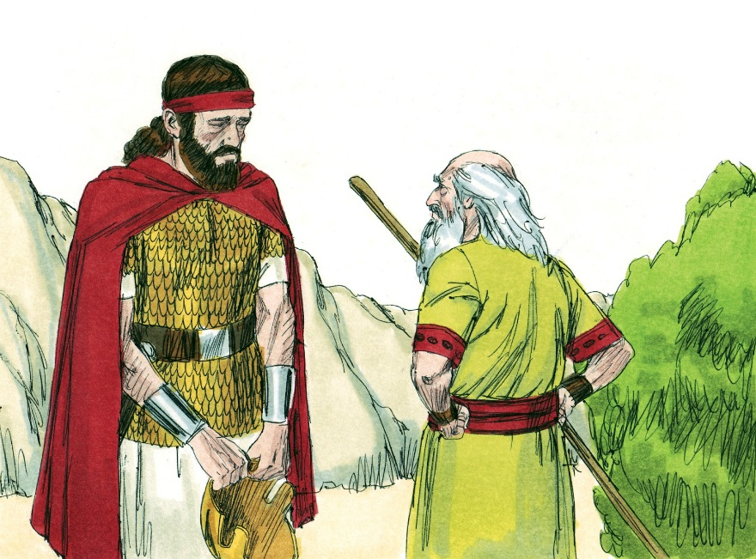
_____ 10. God said to utterly destroy the Amalekites but to save the King.

_____ 11. The Amalekites beat the Israelites and captured Saul.

_____ 12. Saul blamed the people for keeping the best sheep and oxen alive.

_____ 13. It’s all right if we disobey God as long as we give God something in return.

_____ 14. Saul was trying to kill Samuel when he tore his cloak.

_____ 15. Saul repented and changed his ways for the rest of his life.

_____ 16. Saul was surprised that Samuel was angry because Saul thought he had done what God wanted him to do with regard to the Amalekites and the animals.

Fill in the Blanks

17. Saul needed to learn the simple lesson of ________________ carefully and _____________.

18. “Behold, to ___________ is better than ____________________, and to ________________ than the fat of rams.”

19. Saul had done what was ____________________ in his own _______________.

20. Samuel was sent to Bethlehem to anoint ________________ the youngest son of _________ to be the future King in Saul’s place..

Thought Question
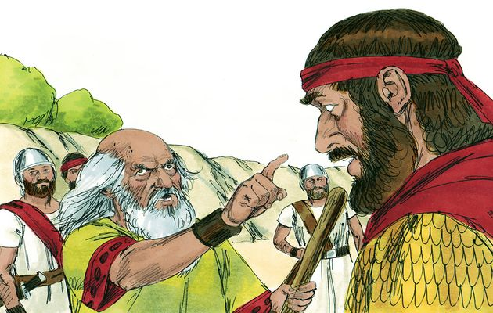
21. What can YOU do now so that God will not reject you, like He rejected Saul?

__________________________________

__________________________________

__________________________________

__________________________________

__________________________________

__________________________________

__________________________________

