CSSA STAGE 2 JUNIOR #20 NAME ___________________________________

God Chooses David

Multiple Choice: Circle ALL the Correct Answers!

1. Samuel went to Bethlehem to:
a) offer a sacrifice b) anoint the new king
c) go to the house of Jesse d) take a vacation

2. When Samuel anointed David:
a) all of David’s brothers watched b) he was only a young boy
c) he became king right away d) God’s spirit came upon him

3. Jesse was:
a) the grandson of Boaz and Ruth b) Saul’s brother
c) David’s father d) a Bethlehemite

4. “God looketh on the heart” means:
a) God knows if we have a healthy heart
b) God knows our thoughts
c) God doesn’t care what we look like on the outside
d) God can see through our skin and see our heart beat

Short Answer

5. What did Samuel think when he saw Jesse’s oldest son, Eliab? _________________________

____________________________________________________________________________

6. Why did God choose David to be king?_____________________________________________

____________________________________________________________________________

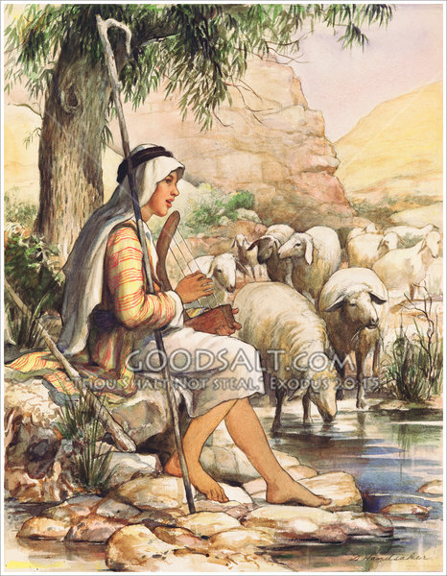
7. What was David doing when Samuel first came to his house?

__________________________________________________

__________________________________________________

8. Name one way that David was like Jesus Christ? ___________

__________________________________________________

__________________________________________________

9. If our thoughts are good, what else will be good too? ________

__________________________________________________

__________________________________________________

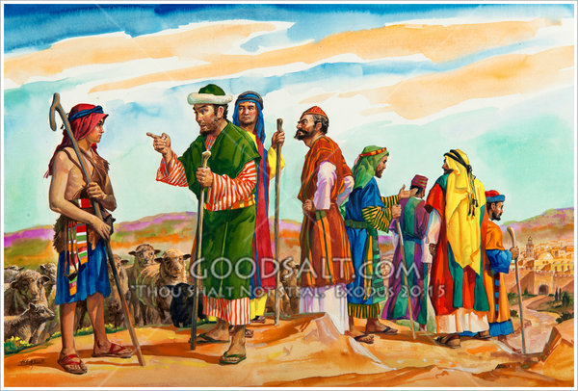
True or False

_____ 10. Jesse had eight sons.

_____ 11. God told Samuel to anoint Eliab.

_____ 12. David was a shepherd.

_____ 13. Samuel poured oil from a pitcher on David’s head.

_____ 14. David was the first king of Israel.

Fill in the Blanks

15. God chose ________________ to replace Saul as king.

16. David was the ____________________ son in his family.

17. David was a man after God’s own ___________________.

18. “for man looketh on the outward _______________________ but Yahweh looketh on the

_______________.”

19. Because Saul was selfish, proud and __________________ it made him unfit to rule

___________________ people.

Thought Questions

20. What does “man after God’s own heart” mean? _____________________________________

________________________________________
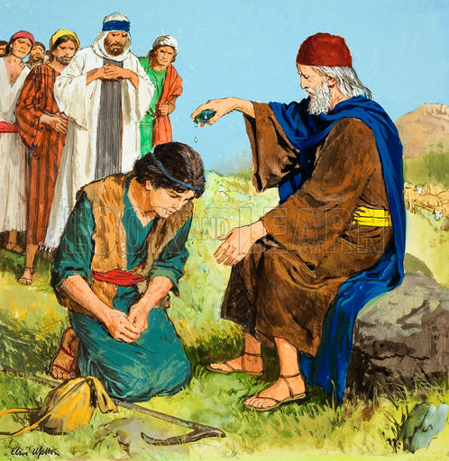
________________________________________

________________________________________

________________________________________

________________________________________

21. Why did God use examples of other people who were like Jesus?

________________________________________

________________________________________

________________________________________

________________________________________

________________________________________

