CSSA STAGE 2 JUNIOR #22 NAME ___________________________________

David and Jonathan

Multiple Choice: Circle ALL the Correct Answers!

1. Jonathan:
a) was Saul’s oldest son b) loved David but was jealous of him
c) realized David would be king next d) was a Godly and faithful man

2. Saul hated David because:
a) he could see God was with David b) the people liked David more than Saul
c) he was rude to Saul d) David took some of Saul’s sheep

3. David did not kill Saul in the cave because:
a) Saul woke up b) he was God’s anointed
c) his men told him not to d) he didn’t have enough time

4. Saul’s last battle was:
a) on Mt Gilboa b) with the Philistines
c) where he and Jonathan died d) when his armor-bearer killed him

Short Answer

5. What did Jonathan give David? ___________________________________________________

____________________________________________________________________________

6. What did Saul want to do to David? _______________________________________________

____________________________________________________________________________

7. How did Jonathan feel about David? _______________________________________________

____________________________________________________________________________
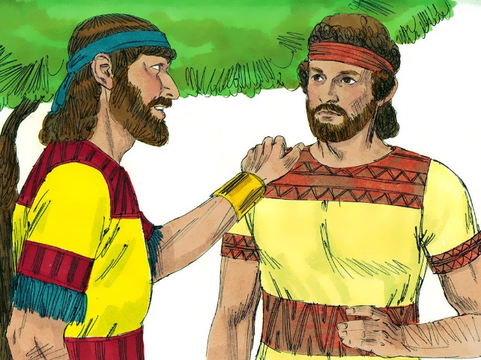
8. What was the covenant they made together? _________

_____________________________________________

_____________________________________________

_____________________________________________

9. David didn’t kill Saul in the cave. What did he do instead?
_____________________________________________

_____________________________________________

_____________________________________________

True or False
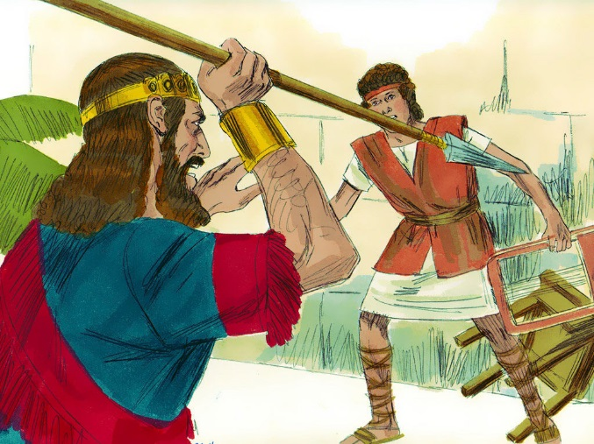
_____ 10. Jonathan was expected to be the next king.

_____ 11. Saul was jealous of David.

_____ 12. Saul was glad David did not come to the feast.

_____ 13. Saul threw a javelin at Jonathan.

_____ 14. David was glad when Saul was dead.

Fill in the Blanks

15. Christ (the Messiah) would later come from the family line of __________________________.

16. “Saul has slain his ______________________ and David his ______ thousands.”

17. David went into hiding because Saul wanted to _______________ him.

18. Because of __________________ and __________________ Saul tried to stop David from being king.

19. David later showed his love for Jonathan when he cared for _______________________, his son.

Thought Question

20. Why do you think David and Jonathan were such good friends? What made them like each other so much?

__________________________________________________________________________

__________________________________________________________________________

__________________________________________________________________________
