CSSA STAGE 2 JUNIOR #23 NAME ___________________________________

David repays Good for Evil

Multiple Choice: Circle ALL the Correct Answers!

1. David had this many men join him while hiding from Saul:
a) 12 b) 1000 c) 600 d) 200

2. David hid in what part of Israel:
a) Area around Galilee b) Hills of Judah
c) He moved through the whole land d) In the southern desert

3. Saul took how many men with him to hunt David:
a) 3000 b) 50
c) 10 000 d) 300

4. What did David take from Saul:
a) his shield b) his sword
c) his crown d) a piece of his robe

5. Some of the lessons we can learn from this story are:
a) we are to remain kind even when others are not kind to us b) love your enemies
c) our lives may not always be easy but we must always follow God’s commandments d) wait patiently for God to fulfill his promises

Short Answer

6. What did David’s men want him to do when Saul came into the cave to rest?
____________________________________________________________________________

7. What reason did David give for not killing Saul when he had the chance? __________________

____________________________________________________________________________

8. What did Saul say to David in response? ____________________________________________________________________________

____________________________________________________________________________

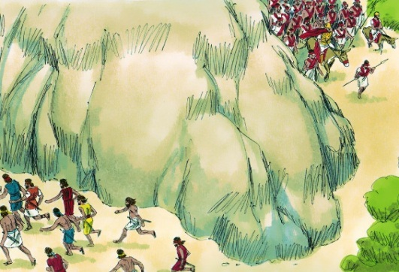
9. Where was David hiding the second time Saul came to hunt for him? _________________________________________

10. What is the name of the captain of Saul’s army?

__________________________________________

True or False
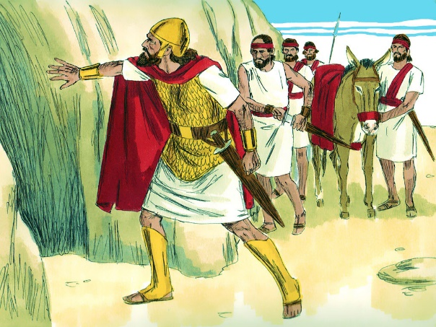
_____ 11. At Saul’s death, David became king over all Israel.

_____ 12. David regretted cutting off Saul’s robe

_____ 13. Asahel went down with David to Saul’s camp at night.

_____ 14. Saul and Abishai were sleeping in the middle of the camp.

_____ 15. David took Saul’s spear and jar of water.

Fill in the Blanks

16. “Thou art more ______________ than I, for thou rewarded me ______, whereas I have

rewarded thee __________...And now, behold I know well that ________ shalt surely be

_________ and that the kingdom of ____________ shall be established in thy _________.”

17. “Destroy _______ not: for who can stretch forth his hand against the LORD’s ____________

and be _________________.

18. “Art thou not a ____________ man? David asked Abner. “Wherefore then hast thou not kept

thy _________ the _________? For there came one of the people in to ____________ the king thy

Lord. This thing is not __________ that thou hast done. As the _____________ liveth, ye are

worthy to _________, because you have not kept your _____________, the LORD’s

________________.

Thought Question

19. What can we learn from David’s Godly attitude in this lesson? _________________________

___________________________________________________________________________

___________________________________________________________________________

