Name:

Lesson 22 – David and Jonathan
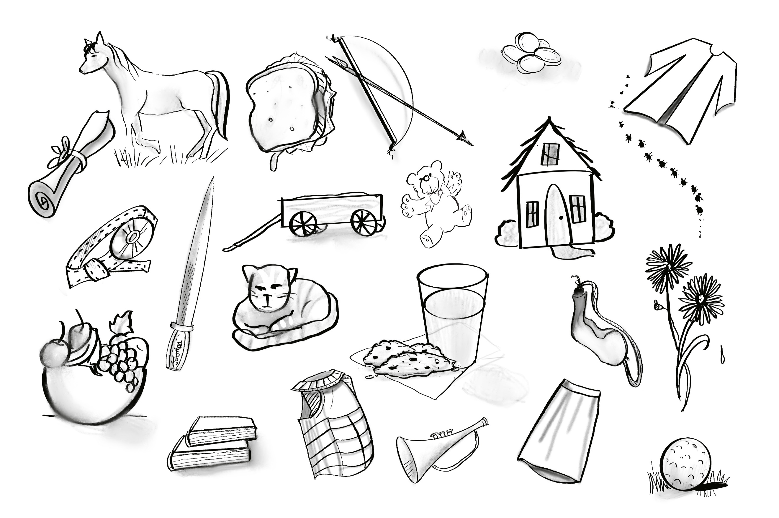
Short Answers

- In the picture opposite, find and circle the five things Jonathan gave to David to show his friendship.

- Was Jonathan jealous David had been chosen to be the next king? (circle the correct answer) YES NO

- What did the women sing in the streets that made Saul angry and jealous?

- On the second day of the feast, where did Jonathan say David had asked to go?

- What did Saul try and do to his own son?

- What did David hear Jonathan call out to the lad after shooting his arrows?

- What did Jonathan say to comfort David when they parted?

- What kind of people should we choose to have as our friends?

- Who is a friend you are thankful for?

Extra Question for 7 and 8 year olds

- How can you be a good friend to others?

See “Memory Verse” page in your binder for this week’s memory verse

