CSSA STAGE 2 JUNIOR #24 NAME ___________________________________

David the King

Multiple Choice: Circle ALL the Correct Answers!

1. David had learned many valuable lessons from being a:
a) shepherd b) soldier c) leader d) carpenter

2. David was anointed to be king:
a) when he was a young shepherd b) 10 years later when he became king of Judah
c) 7½ years later as king over all Israel d) after Saul died

3. Jerusalem was:
a) unconquered for 400 years b) built on a hill
c) protected by high walls d) home to the Jebusites

4. Joab:
a) was one of David’s bravest soldiers b) made his way into Jerusalem by a tunnel
c) died in the battle for Jerusalem d) became captain over David’s army

5. Some of the lessons we can learn from this story are:
a) always pray to God for direction b) you must conquer a city to be in the kingdom
c) read God’s Word every day d) wait patiently for God to fulfill his promises

Short Answer

6. In which book of the Bible did David write about the faith which helped him to wait patiently for God?
____________________________________________________________________________

7. After Saul’s death what did David do before going to Hebron?___________________________

____________________________________________________________________________

8. How did Joab get into the city? ___________________________________________________

____________________________________________________________________________

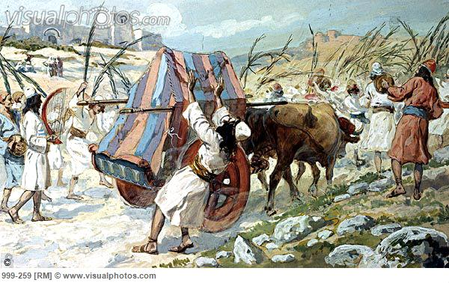
9. Why did God kill Uzzah? _________________________

_____________________________________________

_____________________________________________

10. What happened to the ark three months after Uzzah died?

_____________________________________________

_____________________________________________

True or False
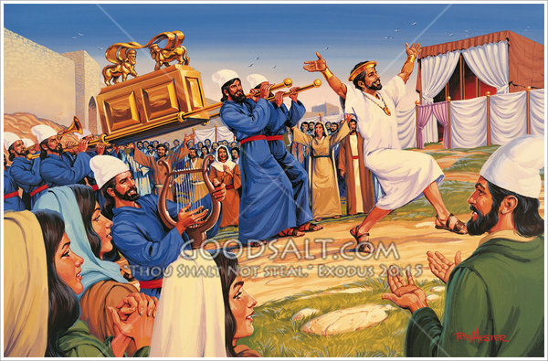
_____ 11. At Saul’s death, David became king over all Israel.

_____ 12. The Jebusites were afraid of David’s army and surrendered with a fight.

_____ 13. At first, David only became king over the tribe of Judah.

_____ 14. David wanted Hebron to be his capital so he could put the ark there.

_____ 15. David forgot to read the law and pray before he moved the ark.

Fill in the Blanks

16. A new cart was made to carry the ark but the ark was supposed to be carried upon the

_____________________ of the Levites.

17. David knew from the law that God had chosen _______________________ as a place to put His Name.

18. Uzzah’s death was a warning to all of the importance of _________________________ and

______________________ the will of God.

19. “We must through much _______________________ enter the Kingdom of God.”

Thought Question

20. How do the words “King” and “Jerusalem” relate to the lives of David and Jesus? ___________

___________________________________________________________________________

___________________________________________________________________________

