CSSA STAGE 2 JUNIOR #25 NAME ___________________________________

God’s Promises to David

Multiple Choice: Circle ALL the Correct Answers!

1. David had a wish to:
a) build a new palace of cedar wood b) build a beautiful temple
c) go to Egypt d) become very rich

2. David’s special descendant would:
a) also be the son of God b) never sin
c) build a temple for God d) live forever

3. Part of the promise made to David was that:
a) he would never die b) he would be raised from the dead
c) he would see Christ rule the Kingdom d) he would have many children

4. God offers us:
a) the same hope that he offered David b) lots of money
c) life with no troubles d) the hope of eternal life in His Kingdom

Short Answer

5. Why didn’t God want David to build Him a temple? ___________________________________

____________________________________________________________________________

6. Who is David’s special descendant that will sit on his restored throne in the Kingdom? ________

____________________________________________________________________________

7. What part of the promises to David did Solomon also fulfill? _____________________________

____________________________________________________________________________

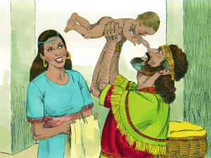
8. Give three ways in which Solomon did not fulfill the promises to David?

- ___________________________________________

___________________________________________

- ___________________________________________

___________________________________________

- ___________________________________________

___________________________________________

True or False
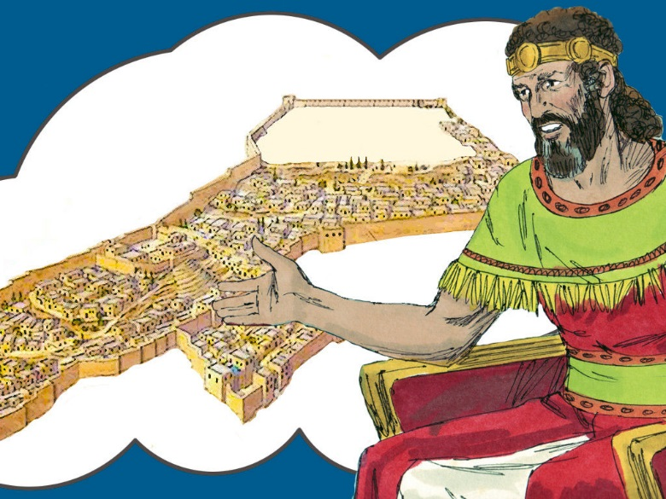
_____ 9. Jesus Christ will fulfill the promises God made to David.

_____ 10. David’s descendant will be king in the Kingdom.

_____ 11. Abraham, Isaac, Jacob and David were all Canaanites.

_____ 12. God was pleased that David wanted to build a temple.

_____ 13. Christ is also waiting to be raised from the dead.

Fill in the Blanks

14. David was a “man after God’s own ____________________.”

15. The name David means ______________________________________________________.

16. The promises made to Abraham, Isaac, Jacob and David are called “the ________________

of Israel.”

17. God told Moses that, “As truly as I live all the _________________ shall be filled with the

______________________ of the Lord.”

Thought Question

18. If we believe in the promises God made to David, what else must we do to share his hope?

__________________________________________________________________________

__________________________________________________________________________
