

Then the Lord God formed man of the _________ from the _________________, and breathed into his _______________ the ______________ of life; and man became a living being. (Gen 2:7)

God created ________ in His own ______________,

in the image of _________ He created him;

male and female He created them.

(Gen 1:27)

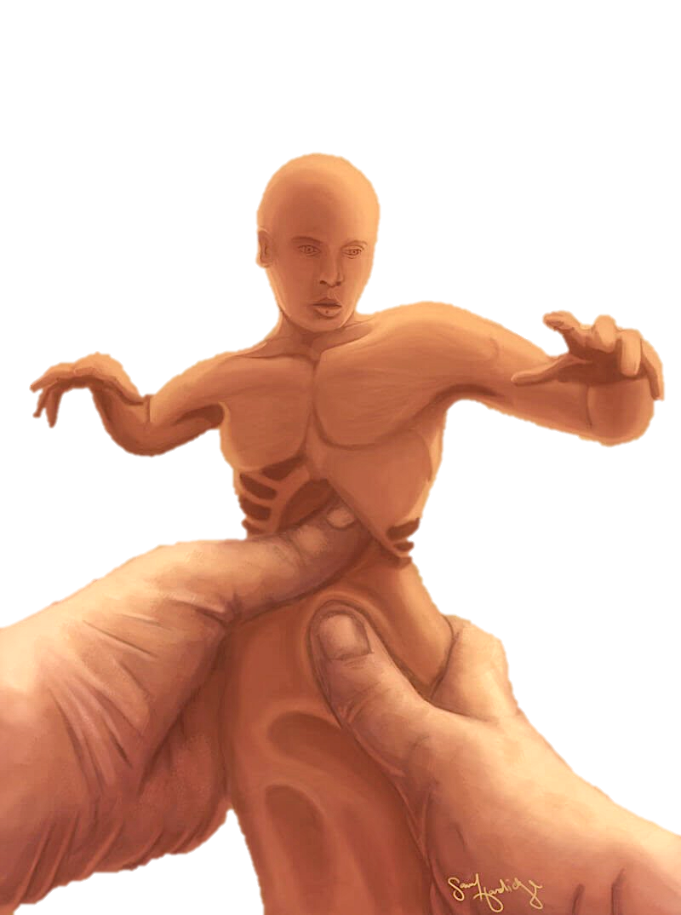

Then the Lord God said, “It is not good for the man to be ______________; I will make him a ____________________ suitable for him.” (Gen 2:18)

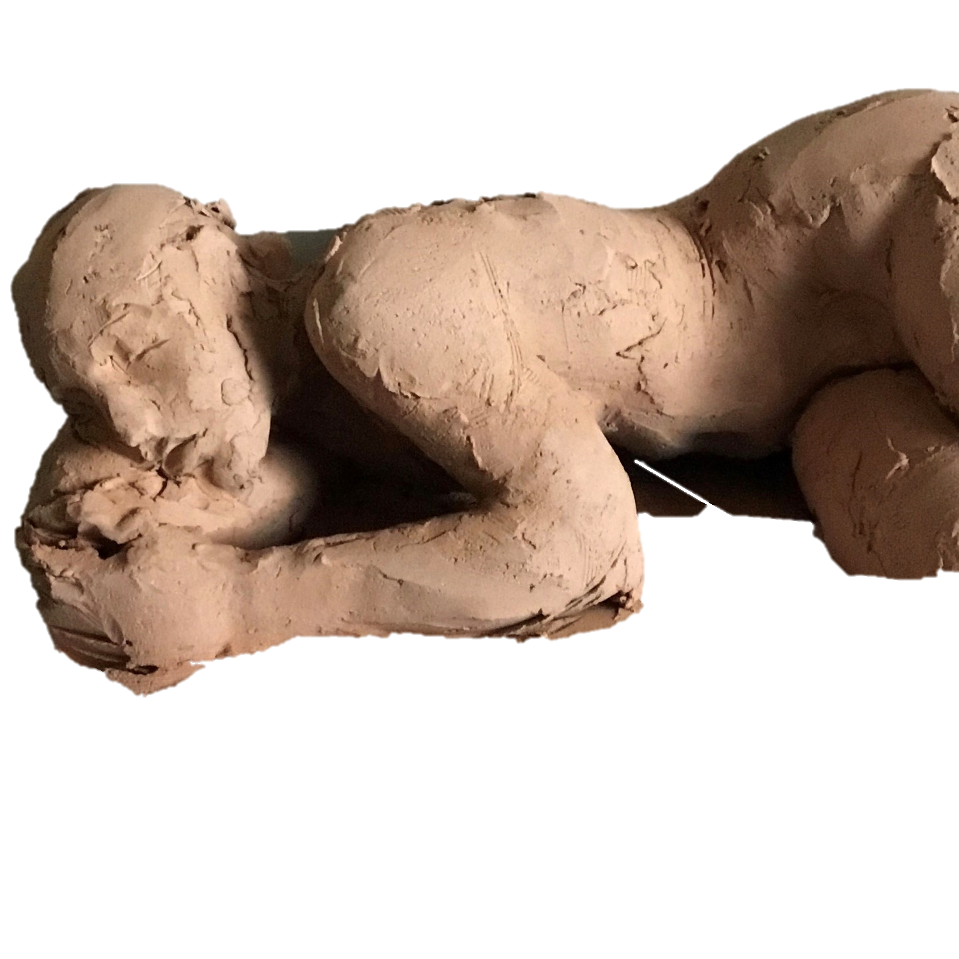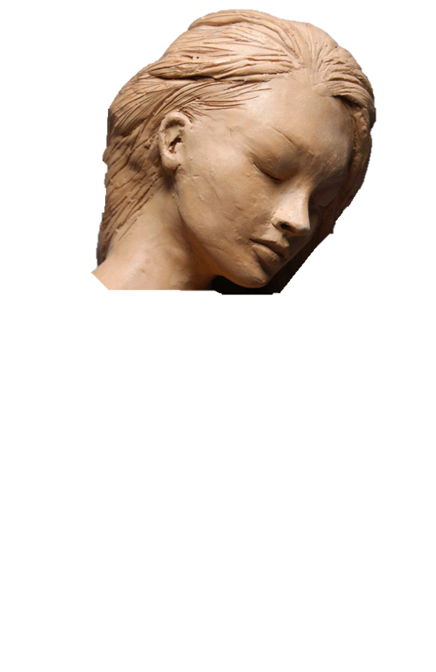

The Lord God fashioned into a ____________

the _________ which He had taken from

the _________, and brought her to the

man. (Gen 2:22)

So the Lord God caused a deep ___________ to fall upon the man,

and he slept; then He took one

of his ________ and closed up the flesh at that place. (Gen 2:21)

