CSSA STAGE 3 JUNIOR #1 Name _______________________________

The Kingdom is Established

2 Samuel 7-9

Multiple Choice: Circle ALL Correct Answers

1. God made David a promise that:
a) David’s seed would sit on his throne forever b) David would never be a shepherd again
c) David’s seed would rule the whole earth d) He would never grow old

2. David couldn’t build a house for God because:
a) David was not strong enough b) David was a man of war
c) David had shed blood d) He would die soon

3. It was David’s work to:
a) build a house for God b) be a shepherd to the people
c) overthrow the enemies around the kingdom d) stay home and relax

4. Mephibosheth was lame because:
a) he was born that way b) his feet had been cut off
c) his nurse fell with him when he was young d) he broke his legs

Short Answer

5. How many years had it been since God had sent Samuel to anoint David? _________ __

6. What did David want to do to show his thankfulness for the great promises God had given him?

7. What promise had David made to Jonathan? _________________ __

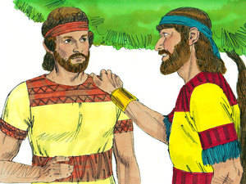

8. What 2 things did David do for Mephibosheth?

________________________________________

________________________________________

9. What wicked thing had David done concerning

Bathsheba? ___________________________

________________________________________

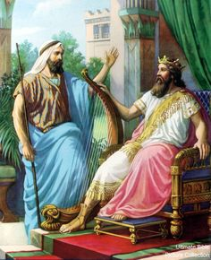
True or False

________ 10. David was now king in Bethlehem.

________ 11. Jonathan had one son left named
Mephibosheth.

________ 12. David fought seven campaigns to defeat
Israel’s enemies.

________ 13. Uriah was Bathsheba’s husband.

________ 14. David never made any mistakes in his life.

Fill in the Blank

15. God sent ___________________ the prophet to speak to David.

16. David was now king in the city of ___________________________ .

17. ______________________ was the servant put in charge of Mephibosheth’s land.

18. David arranged for _____________________ to be killed in battle.

19. We must _____________________ ourselves as David did and admit when we have
done wrong.

Thought Question

20. Why didn’t God put David to death for his terrible sins with Bathsheba and Uriah?

________________________________________________________________________

________________________________________________________________________

