CSSA STAGE 3 JUNIOR #10 NAME ___________________________________

Elisha & the Shunammite Woman

Multiple Choice: Circle ALL the Correct Answers!

1. The Shunammite woman:
a) was a faithful woman b) made Elisha a boat
c) asked Elisha for a son d) didn’t tell her husband as soon as their son died

2. The Shunammite woman’s son:
a) died in the field with his father b) was placed on Elisha’s bed
c) was raised by Gehazi d) sneezed seven times

3. Elisha:
a) traveled from city to city b) knew only God had the power to raise the dead
c) was given a room with a TV d) told Gehazi to try and raise the Shunammite’s son

4. The Shunammite’s husband:
a) was old b) worked in the field
c) knew his son’s head hurt d) carried his son back to his mother

5. Gehazi:
a) was Elisha’s servant b) knew what the Shunammite woman would want
c) couldn’t raise the son d) tried to thrust the Shunammite woman from Elisha

Short Answer

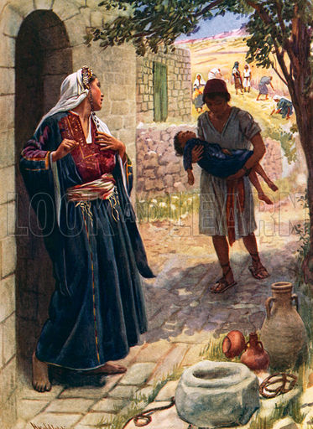
6. What did the kind Shunammite woman do for Elisha? ________________________________________

________________________________________.

7. What did Elisha say God would do for her because of her kindness? ________________________________________

________________________________________.

8 . What happened to the Shunammite’s son? _______________________________________.

9. Who did the Shunammite woman go to see when her son died? ______________________.

10. After Elisha prayed, what did he do to bring the boy back to life? ___________________________________

______________________________________________

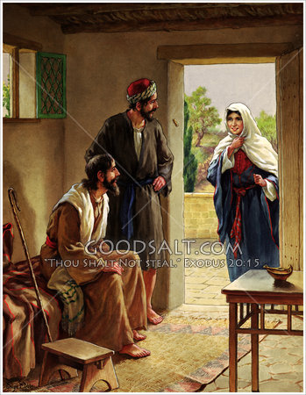
True or False

_______ 11. Elisha wanted a bigger room.

_______ 12. Elisha didn’t know what good thing to do for the
Shunammite woman to thank her for the room,
so he asked Gehazi.

_______ 13. Elisha knew as soon as he saw the
Shunammite woman coming on a donkey that
her son had died.

_______ 14. The Shunammite woman ran back with Gehazi to
see if he could raise her son.

_______ 15. When the Shunammite’s son was raised, the very
first thing she did was pick him up.

Fill in the Blanks

16. God knows our hearts and will ____________________ us for our righteousness.

17. She has no _________ and her husband is ___________.

18. Elisha gave Gehazi his _______________ and ordered him to make all haste back to the
Shunammite’s house.

19. He (Elisha) ____________________ to God for he knew that he had no power of his own.

20. We must ________________ God because we love him and are _____________________ for
all his daily blessings.

Thought Questions

21. Why did the Shunammite woman tell Gehazi all was well (when her son had just died), and then

she stayed with Elisha rather than follow Gehazi back to her dead son? ___________________

_____________________________________________________________________________

22. Why couldn’t Gehazi raise the Shunammite woman’s dead son? ________________________

____________________________________________________________________________.
