CSSA STAGE 3 JUNIOR #11 NAME ___________________________________

Naaman the Leper

Multiple Choice: Circle ALL Correct Answers!
1. Naaman was:
a) king of Syria b) a leper
c) a mighty man of valor d) captain of the Syrian army

2. The little servant girl:
a) lived with Naaman b) was treated well
c) remembered Elisha’s miracles d) felt sorry for Naaman

3. Naaman brought gifts of:
a) horses b) gold c) silver d) clothes

4. Gehazi:
a) was Elisha’s servant b) asked for gifts from Naaman
c) told many lies d) was struck dead

5. Leprosy:
a) can’t be cured b) makes body parts decay and die
c) makes your skin turn red d) is like sin

Short Answer

6. How did the little Jewish servant girl end up in Syria? ________________________________

__________________________________________________________________________

7. What did Elisha say Naaman was supposed to do to be healed?
______________________________________________
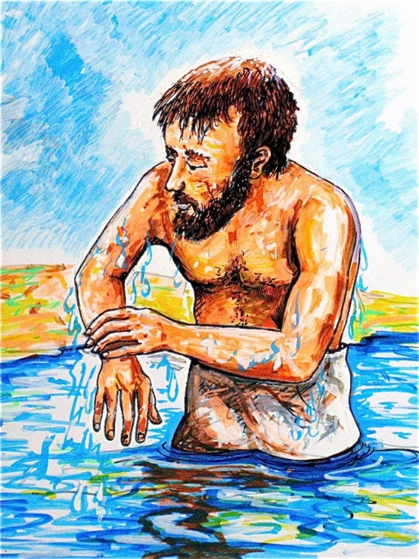
______________________________________________

8. How did Naaman feel about this?
______________________________________________

______________________________________________

9. What happened to Gehazi because of his greed?
______________________________________________

______________________________________________

10. Besides washing in the Jordan, what was necessary for

Naaman to do to be healed?
______________________________________________

______________________________________________
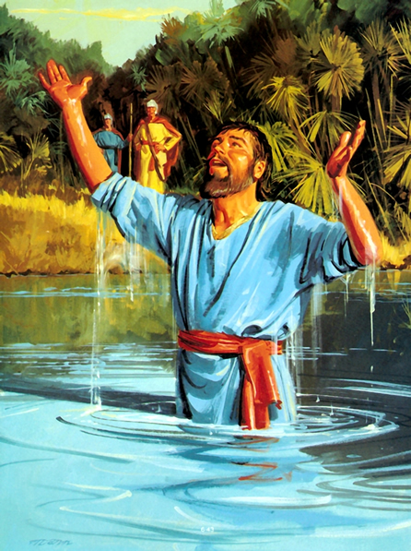
True or False

__________ 11. Elisha was welcome in the courts of the
kings of Israel.

__________ 12. Syria was south of Israel.

__________ 13. Naaman washed six times in the Jordan
River.

__________ 14. The little maid had more faith than the
king of Israel.

__________ 15. Joram was the king of Israel.

Fill in the Blank

16. Elisha prophesied for at least __________________
years.

17. Elisha sent his servant, _________________ to tell Naaman what to do.

18. The first act of ____________________ to God is baptism.

19. It was the power of _______________ that healed Naaman.

20. Naaman was cured because of his __________________ to the prophet’s command.

Thought Question

21. Since leprosy is like sin and Naaman’s washing in the Jordan was like baptism, what lesson

can we learn from Naaman’s cleansing? _________________________________________

__________________________________________________________________________

