CSSA STAGE 3 JUNIOR #12 NAME ___________________________________

Judgment on the House of Ahab (Jehu)

Multiple Choice: Circle ALL the Correct Answers!

1. Jehu was:
a) the son of Ahab b) a captain of the army of Israel
c) told to kill the whole family of Ahab d) anointed to be king of Israel

2. Joram was:
a) the king of Israel b) recovering from the chicken pox
c) related to Ahaziah, king of Judah d) with Ahaziah when Jehu came to kill him

3. Jezebel was:
a) afraid and hid when Jehu came b) bold, painted her face and challenged Jehu
c) thrown out of the window and died d) buried in the tombs of the Kings

4. Jehu:
a) had the 70 sons of Ahab killed b) killed the worshippers of Baal
c) killed the worshippers of God d) destroyed the idols of Baal

5. Lessons from this story are:
a) you cannot worship God and Baal b) if we love God we will hate evil
c) don’t get the chicken pox d) God will destroy the wicked

Short Answer

6. Why did Ahaziah go to Jezreel?__________________________________________________

7. Why did Jehu go to Jezreel?
___________________________________________________________________________

___________________________________________________________________________

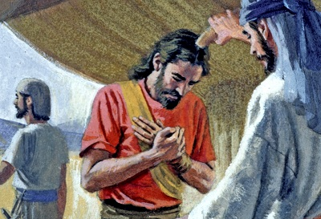
8. What did Jehu tell the men in the palace to do
with Jezebel?
____________________________________

____________________________________

9. Who had prophesied how Jezebel would die?
____________________________________

10. Jehu planned a clever way to destroy the
worshippers of Baal. What was his plan and
how did he make sure no servants of God
were destroyed?
___________________________________

___________________________________

____________________________________________________________________________
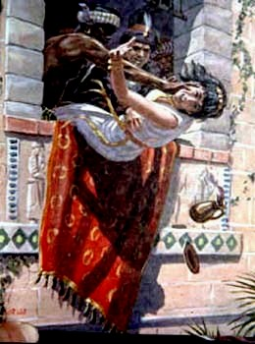
True or False

_______11. King Ahab was killed in battle with the
King of Syria.

_______12. God chose Jehu to be a priest.

_______13. After the death of Ahab, Jezebel
repented and turned to God.

_______14. Joram killed Ahaziah.

_______15. Joram and Ahaziah were both
descendants of Ahab.

Fill in the Blanks

16. We must ________________ God with all our hearts and
______________ all the ways of wickedness.

17. The whole house of Ahab shall ______________.

18. Joram was Ahaziah’s _________________.

19. Jehu took up his bow and with all his might __________ an arrow at Joram.

20. All that was left of Jezebel were the ____________, and the _____________ and the palms of

her _______________. (2Kings 9:35 NKJV)

Thought Question

21. Jehu destroyed Baal and the worshippers of Baal but Jehu did not truly follow Yahweh himself.

What can we learn from his life? __________________________________________________

____________________________________________________________________________

