CSSA STAGE 3 JUNIOR #2 & 3 Name _______________________________

The Wisdom & Temple of Solomon

Multiple Choice: Circle ALL Correct Answers

1. These men remained faithful to King David:
a) Joab b) Abiathar c) Nathan d) Zadok

2. Solomon was like Christ because he:
a) received wisdom b) was the son of David c) was called peaceable d) never sinned

3. David gathered the supplies to build the Temple from the:
a) enemies he conquered b) princes and captains of Israel c) people d) angels

4. The Temple was like the Tabernacle because both were:
a) the same size b) movable c) places of worship d) divided into two rooms

5. During the dedication of the Temple:
a) the cloud of glory filled the Temple b) Solomon prayed
c) the priests brought the ark in d) fire fell from heaven

Short Answer

6. What are the names of David’s two sons who tried to take the kingdom from him near the

end of his reign? _____________________________________________________________.

7. What was the first thing Solomon did when he became king? __________________________

___________________________________________________________________________.

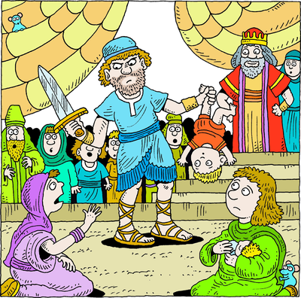
8. When God appeared to Solomon in a dream, what did
He ask for and what did he receive?

_________________________________________

_________________________________________.

9. How did Solomon identify the true mother of the
living baby? ________________________________

__________________________________________

10. What kind of “Temple” is God building today and

who are the stones? ________________________

__________________________________________

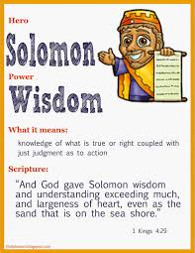
True or False

11. _____ David reigned 7.5 years in Hebron and 33
years in Jerusalem.

12. _____ God chose Solomon to be king.

13. _____ Solomon asked Hiram to help him in
building the Temple.

14. _____ Jerusalem was filled with the noise of the
workers as they banged the hammers at
the Temple site.

15. _____ At the end of Solomon’s prayer of thanks for the
Temple, fire fell from heaven and burned up the
people.

Fill in the Blank

16. David’s name means __________________________.

17. Solomon’s name means ______________________________.

18. Solomon began to build (the Temple) in the _______ year of his reign and it was finished in the _______ year.

19. Solomon prayed that even if Israel was taken captive that God would ___________ them and bring them back to the Land.

20. Let us try hard now to ________________ God’s ways and be wise so we will be able to be

part of that __________________ God will set up on earth.

Thought Question

21. How do you become wise?_____________________________________________________

__________________________________________________________________________

__________________________________________________________________________.
