CSSA STAGE 3 JUNIOR #5 NAME ___________________________________

The Kingdom Is Divided

Multiple Choice: Circle ALL the Correct Answers!
1. What three things had God warned kings NOT to do?
a) build big buildings b) have a lot of horses
c) have a lot of wives d) have much silver and gold

2. When Rehoboam became king, the people wanted him to:
a) make more beautiful buildings b) make things easier for them
c) make their taxes less d) reign in Shechem

3. The young men advised Rehoboam to:
a) do as the people wanted b) make idols for the people
c) make things even harder for the people d) give the people extra food

4. God told Solomon that:
a) Rehoboam would be a great king b) the kingdom would be given to someone else
c) Judah and Benjamin would stay under d) Rehoboam would be wise like him
the reign of David’s descendants

5. To keep the people from returning to Jerusalem for worship, Jeroboam:
a) made a wall around his kingdom b) made idols for the people to worship
c) made a feast day d) picked new priests

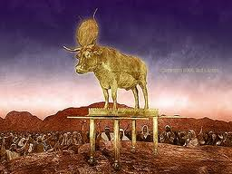
Short Answer

6. What did Solomon have to do in order for “the throne of his kingdom to be established upon Israel forever”?
__________________________________________

__________________________________________

7. What finally led Solomon away from true worship of God?_____________________________________

8. How did God stop Rehoboam from fighting against the other ten tribes? ________________________________________________________________________________ _______________________________________________________________ _

9. What did Jeroboam make for the people to worship? _________________________________

10. What did Jeroboam say these new gods had done for the people? ______________________

______________________________________________________________________________
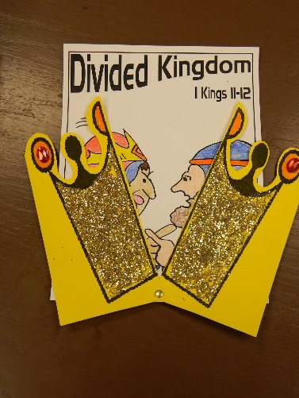
True or False

11. __________ Solomon reigned for 40 years.

12. __________ Judah and Benjamin stayed faithful to Rehoboam.

13. __________ Jeroboam did not know he would become king one day.

14. __________ Solomon never turned from true worship to God.

15. __________ The young men’s advice caused the people to rebel.

Fill in the Blank
16. Solomon’s wisdom brought __________________ and ________________ to Israel. His

foolish sins would bring great ___________________ and ______________ to God’s people.

17. The people chose __________________ as the leader and set him up as king in __________

18. The 10 tribes were in the _______________ and were known as the kingdom of __________

The 2 tribes were in the _______________ and were known as the kingdom of ___________

19. Jeroboam put golden calves in __________________ and _____________________ .

20. Solomon allowed the _____________________ of the world to take the place of __________

Thought Question

21. What did God say every king must do? ___________________________________________

What does God want US to do every day? ________________________________________

