CSSA STAGE 3 JUNIOR #6 NAME ___________________________________

Elijah the Prophet

Multiple Choice: Circle ALL the Correct Answers!

1. What commandment had Israel forgotten?
a) do not kill b) do not lie
c) do not make any graven images d) love your neighbor

2. During the famine (drought) God sent Elijah to:
a) Jerusalem b) the Brook Cherith
c) Zarephath d) a widow

3. What did Elijah say would happen if the widow cared for him first?
a) God would send rain that day b) her meal & oil would not run out
c) she would have another son d) she would never die

4. What did Elijah do to bring back the widow’s son from death?
a) prayed to God for help b) stretched over him 3 times
c) took him to his room d) wrapped him in a blanket

Short Answer

5. What does 1 Kings 16:30 say about King Ahab? ____________________________________

___________________________________________________________________________

6. Who did King Ahab marry? _____________________________________________________

7. What god did Jezebel and Ahab worship? _________________________________________

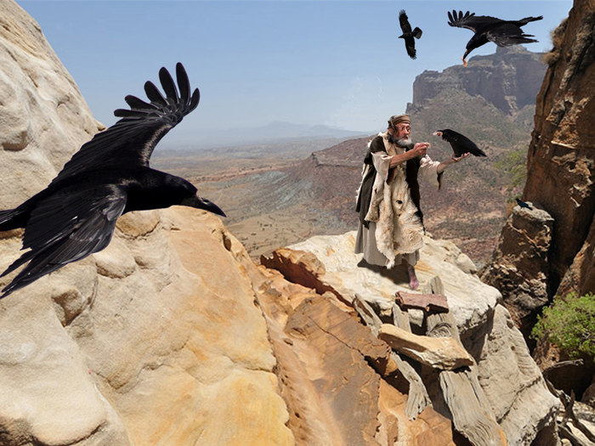
8. Why did God send the famine in the land?

____________________________________________

____________________________________________

9. What did Elijah ask the widow to do for him?

____________________________________________

____________________________________________

True or False

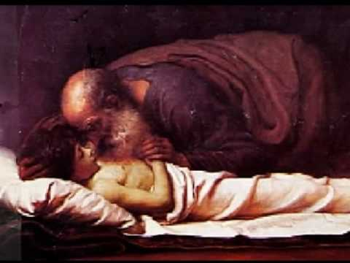
__________ 10. Jezebel was the daughter of the king
of the Zidonians.

__________ 11. Elijah was a prophet.

__________ 12. Ahab worshipped Yahweh the God of
Israel.

__________ 13. The widow’s son was really sleeping,
not dead.

__________ 14. The widow didn’t trust Elijah.

Fill in the Blank

15. God sent _________________ to provide for Elijah at the Brook Cherith.

16. Zarephath was in _________________________ .

17. If we have such ______________________ as the widow, God will provide for our needs too.

18. Ahab made a temple for _____________________ in Samaria.

Thought Questions

19. God saw that the widow of Zarephath was a different kind of person than the wicked people

of Israel who would not listen to His word. What was different about her? _______________

_________________________________________________________________________

20. Ahab married Jezebel, a wicked non-Jewish woman who encouraged him to serve Baal.

What kind of people should we choose to be our friends? ____________________________

__________________________________________________________________________
