CSSA STAGE 3 JUNIOR #7 & 8 NAME ___________________________________

Contest on Mt Carmel and The Still Small Voice

Multiple Choice: Circle ALL the Correct Answers!

1. The 450 prophets of Baal:
a) refused to come to the sacrifice b) prayed to Baal from morning to noon
c) cut themselves d) were killed

2. Elijah:
a) blamed Ahab for the drought b) repaired the altar of God
c) prayed to God to send fire d) poured barrels of water around the altar

3. Elijah went to Horeb because:
a) he was lonely and depressed b) he thought he was the only faithful prophet of God left
c) he loved mountain climbing d) he knew it was the mount of God

4. God answered Elijah in a:
a) earthquake b) wind c) fire d) still small voice

5. God was trying to tell Elijah through the small voice that:
a) mighty miracles alone would not convert the people b) there was no one left in Israel
c) Israel needed to be gently taught by a small voice d) Elijah must go back to Israel

Fill in the Blank

16. Ahab had learned ______________ in the past three years of the drought.

17. The God that answers by __________ let him be God.

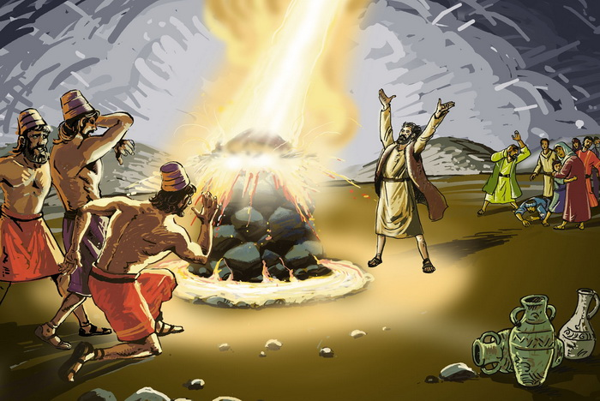
18. Elijah sent his servant

__________ times to see if the

rain was coming.

19. What Israel needed now was the

still small _____________

to teach them ____________

ways.

20. The still small voice speaks to us

from the _____________.

True or False
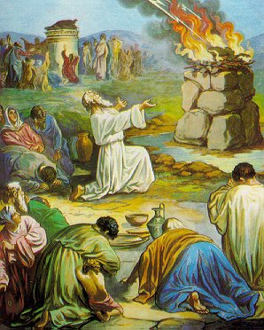
_______ 11. Obadiah feared God.

_______ 12. The priests of Baal turned to worship God.

_______ 13. God sent a rain cloud in the shape of a man’s hand.

_______ 14. Elijah thought he was the only faithful prophet left in
Israel.

_______ 15. Jezebel repented and turned to the worship of the
one true God.

Short Answer

6. Elijah hid from Ahab for 3.5 years during the drought. What did God tell Elijah to do at the end

of the 3.5 years?______________________________________________________________

7. Why did Elijah suggest having a contest on Mt. Carmel and who was the contest between?

___________________________________________________________________________

___________________________________________________________________________

8. What was the contest Elijah arranged? ___________________________________________

___________________________________________________________________________

9. Elijah had faced death with great courage in the past. Why was he so discouraged when he

heard Jezebel was going to kill him? _____________________________________________

___________________________________________________________________________

10. Elijah fled to the wilderness, received food from an angel and traveled to Mt. Horeb. What is another name for Horeb? _____________________

Look on a Bible map and put an X on the approximate location of Mt. Horeb. Name one thing that happened at Mt. Horeb.

___________________________________________________________________________

___________________________________________________________________________

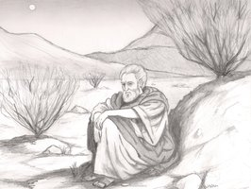
Find each of the following on your maps

1) Mount Carmel 2) Brook Cherith
3) Samaria 4) Sidon
5) Zarephath 6) Jerusalem
7) Sea of Galilee 8) Dead Sea
9) Jordan River 10) Mediterranean Sea

