CSSA STAGE 3 JUNIOR #9 NAME ___________________________________

Elisha Continues God’s Work

Multiple Choice: Circle ALL the Correct Answers!

1. What did Elijah do to Elisha when he first saw him?
a) hugged him b) …invited him to have lunch c) put his mantle on him d) hit him

2. Elisha would now learn as much as he could about:
a) being a farmer b) teaching God’s people c) new cities d) being a shepherd

3. What miracle did Elijah do at the river Jordan?
a) he walked across on the water b) he parted the river
c) he turned the river to blood d) he made it rain

4. Elijah was taken by:
a) angels of God b) a whirlwind c) the sons of the prophets d) wild animals

5. Elisha crossed back over the Jordan River by:
a) a boat b) a miracle c) parting the river like Elijah d) God’s power

Short Answer

6. What was Elisha doing when Elijah found him? _____________________________________

___________________________________________________________________________

7. Who were the “sons of the prophets”? ____________________________________________

8. What did it mean when Elisha asked for a double portion of Elijah’s spirit?
___________________________________________________________________________

___________________________________________________________________________

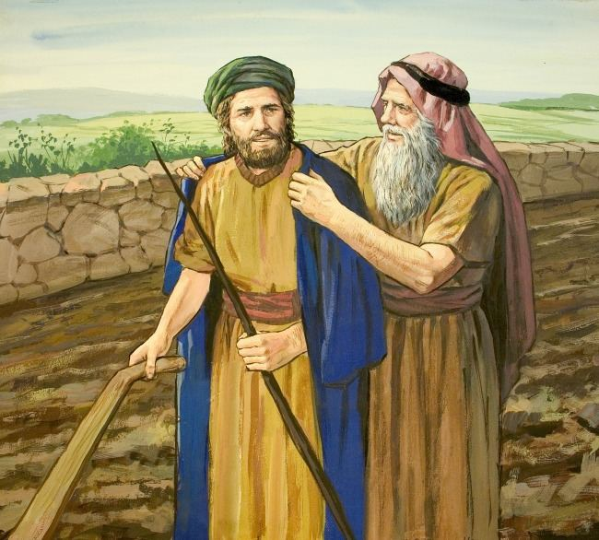
9. What did Elisha have to see in order to receive a

double portion of Elijah’s spirit?
______________________________________

______________________________________

10. What did the sons of the prophets say when they
saw Elisha return after Elijah was taken?

_______________________________________

_______________________________________

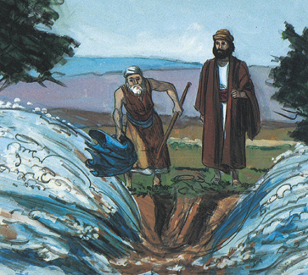
True or False

__________ 11. Elisha was the son of Shaphat.

__________ 12. Elisha was a shepherd before he became
a prophet.

__________ 13. Elijah was taken away while in Jericho.

__________ 14. The sons of the prophets knew Elijah
would be taken.

__________ 15. Elisha didn’t want to leave Elijah.

Fill in the Blank:

16. _____________________ was chosen to take Elijah’s place.

17. Elijah took off his ________________ and put it on Elisha.

18. Elijah hit the river ___________________ with his mantle and it parted.

19. Chariots and horses of __________________ parted Elijah and Elisha.

20. Elisha asked for a ________________ __________________ of Elijah’s spirit.

Thought Question:

21. How should we be like the sons of the prophets? ___________________________________

__________________________________________________________________________

