Circle the answer:

1. David made a promise to Jonathan that:
- He would take good care of the sword Jonathan gave him
- He would look after Jonathans children when Jonathan died
- He would make Jonathan the captain of his army

Lesson 1 – David’s Kindness to Jonathan’s Son
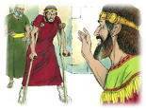

2. What was the name of Jonathan’s son that David helped?

Fill in the Blank:

3. Mephibosheth was only ________ years old when his father _____________________ died. When his nurse heard the news of Jonathan’s death, she became frightened. She picked the little boy up in her arms and ___________ away with him. In her hurry she ____________________ him. This left him lame in both his ________________, for the rest of his life.

True or False? Circle the right answer
True or False

4. Mephibosheth came to live at Jerusalem and eat bread at the kings table.

Thought Question:

David’s kindness to Mephibosheth is like God’s kindness to us. What are some of the kind things that God has done for us?

Lessons for Us
We need to show kindness to others like David did to Mephibosheth. Draw a picture of you doing something kind for someone else.

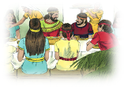

Print the first letter of the animal in the box to see the secret word.

We must make sure that we always keep our

