Lesson 2 – The Wisdom of Solomon
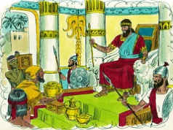
- Who became the next king while David was still alive?

True or False? Circle the right answer
True or False

2. God spoke to Solomon in a dream at Gibeon.

4. What did God give to Solomon as well as wisdom?
- Riches and honour
- A new chariot
- A long life IF he obeyed God

(HINT – there are two right answers!)
Circle the answer:

3. Solomon asked God to give him:
- Riches
- A long life
- Peace from his enemies
- Wisdom

Thinking Question:

5. Why did Solomon want God to give him wisdom?
What Happened First?
Number the circles from 1 to 5 to put the story in the right order

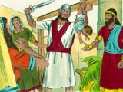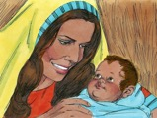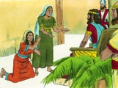
Two women came to Solomon. They both lived in the same house and both had given birth to baby boys. During the night one of the babies died.
Solomon asked for a sword to be brought and have the baby cut in two, giving half to each of the women.
Solomon knew who the real mother was because true mothers care for their babies. He gave the baby to his real mother.

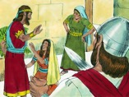
Each of the women said that the living baby belonged to them. They argued before the king.
The true mother did not want the baby killed so she pleaded with Solomon to give the baby to the other woman.

Lesson for Us

God’s wisdom is the greatest thing we can ever have. Where can we find God’s wisdom?
Draw a picture of it here along with your answer

