Lesson 3 – The Glory of Solomon
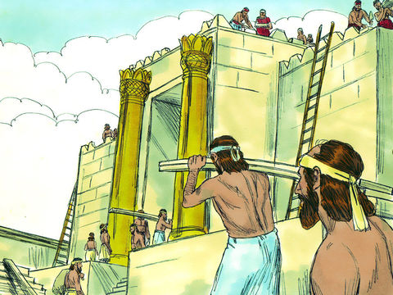
- What did Solomon build for God?

2. Circle all the things that Solomon used to build the Temple:

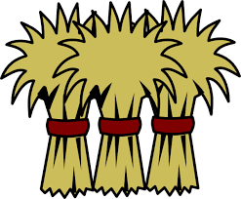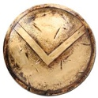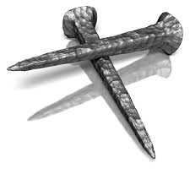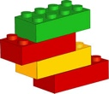
Lego
Iron
Brass
Straw
Gold

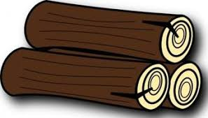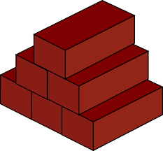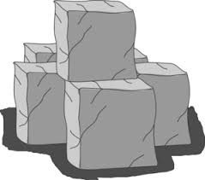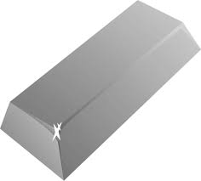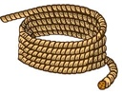
Rope
Stone
Silver
Bricks
Timber

Circle the right word to fill in the blank:

3. God was pleased with Solomon’s work. The ______________________ of his _____________________________ filled the temple.

cloud / rainbow

anger / glory

4. Who gave Solomon his riches?

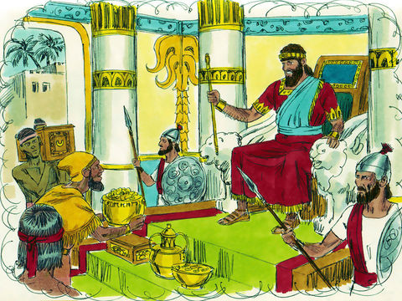
Circle the right answer:
5. Who came to visit Solomon?
- Hiram King of Tyre
- Queen Esther
- The Queen of Sheba
- Pharaoh King of Egypt

Thinking Question:

5. What did the queen of Sheba say after she had spoken to Solomon and had seen all his riches?
Lesson for Us

Solomon was a great king but we are waiting for the greatest King – Our Lord Jesus Christ. He will also build a temple in Jerusalem as part of his Kingdom. People from all countries of the earth will come there to learn about God and His ways. Use your imagination and draw a picture of that kingdom to come.

