- Draw a line from the name of the person to who they are:

Lesson 4 – God Feeds Elijah

Wicked wife of King Ahab of Israel
Elijah

The faithful prophet of God
Ahab

A faithful woman who did all Elijah asked
Jezebel

Wicked King of Israel
The Widow of Zarephath

True or False? Circle the right answer
2. God sent a drought on Israel in the time of Ahab because of their wickedness in worshipping Baal.
True or False

Dot to Dot:
3. Complete the dot to dot to find out what fed Elijah at the brook Cherith – Color him too!

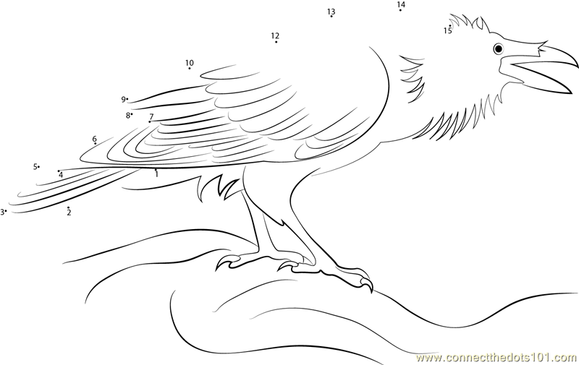
4. When the brook ran dry, God sent Elijah to Zarephath. There was a widow woman there that would feed him. What did the widow woman give Elijah to eat?

Thought Question:

5. How did the widow of Zarephath show that she had faith in God, and how was she blessed?
Lessons for Us

God provided for Elijah in his need and He provides for us too. Draw some of the things that God has blessed you with in your life.

