Lesson 5 – Elijah Raises the Widow’s Son
True or False? Circle the right answer
True or False

1. God provided food for the widow at Zarephath. Her barrel of meal never ran out and her jar of oil never ran dry.

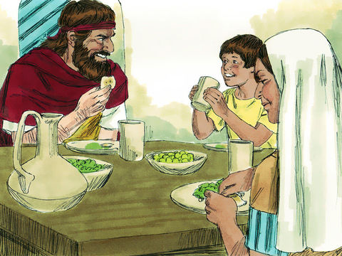
2. What happened to the widow’s son?

What Happened First?
3. Number the circles from 1 to 4 to put the story in the right order

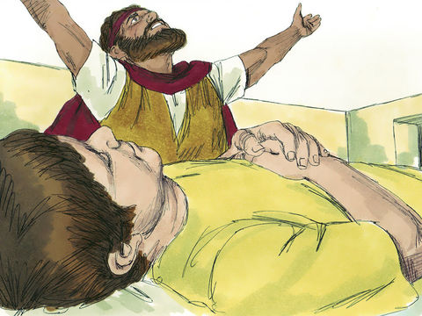
Elijah took the child to his room and laid him on his own bed. He cried out to God in prayer, “Oh Yahweh my God, have you brought evil upon this widow with whom I am staying, by killing her son?”
Then he stretched himself upon the child. He did this 3 times. He again turned to God in prayer and said, “O Yahweh my God I pray thee, let this child live again.”

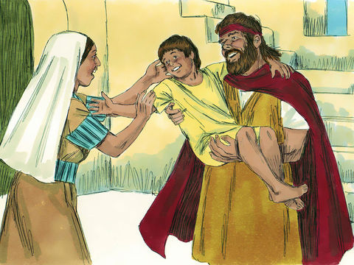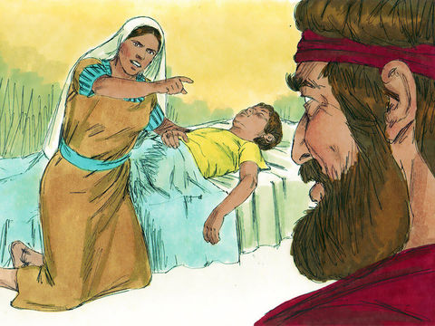
God heard Elijah’s prayer and the child began to breath again! Elijah then brought the child to his mother and gave him to her.
The widow’s son became sick and died. She didn’t understand why this had happened, so she turned to the prophet Elijah.
Circle the right answer to fill in the blank:
God / Baal
4. The widow said to Elijah, “Now I know that you are a man of ______________________________. The word of Yahweh which you speak is _________________________.”
false / true
Circle the answer:

3. From the story of Elijah raising the widow’s son, who alone has the power to bring the dead back to life?
- Elijah
- The widow
- God
- King Ahab

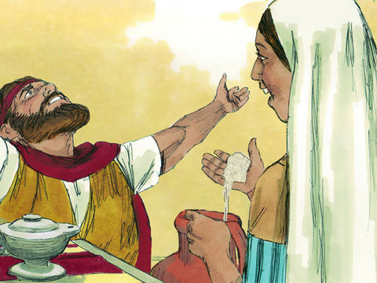

Thinking Question:

5. What does the word “Resurrection” mean?
Lesson for Us

Jesus is coming back soon to raise the dead and set up the Kingdom! Draw someone that you are looking forward to seeing in the kingdom that is asleep in the grave right now.

