Circle the answer:

1. Elijah left the widow’s house at Zarephath because
- They ran out of food
- The brook started flowing again so he went back to the ravens
- God told him to go back to Israel to see King Ahab
Lesson 6 – The Contest on Mount Carmel
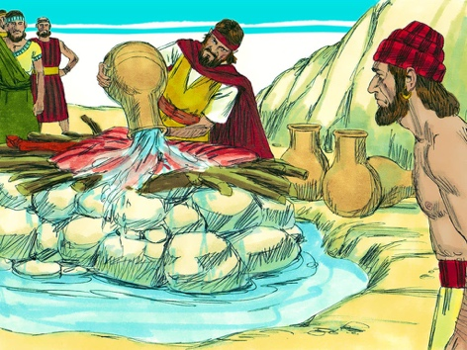

2. Where did the contest between the prophets of Baal and Elijah take place?

True or False? Circle the right answer
3. The God who sent fire to burn the sacrifice on the alter would be the true God

True or False

Fill in the Blank:

4. The Prophets of Baal prepared their sacrifice first. They called “O Baal hear us!” but there was ____________ answer. They called louder, but still _____________ answer. They shouted! They danced! They cut themselves, but still ______________ answer. Baal was an idol, and idols of wood and stone have ____________ power.
How Many? Circle the right answer.
5. How many stones did Elijah use to build his alter?
6. How many barrels of water were poured over the sacrifice?

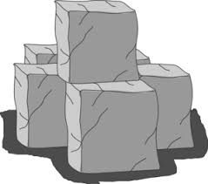
12
10
3
5
12
7

Draw a picture of God’s answer to Elijah’s prayer

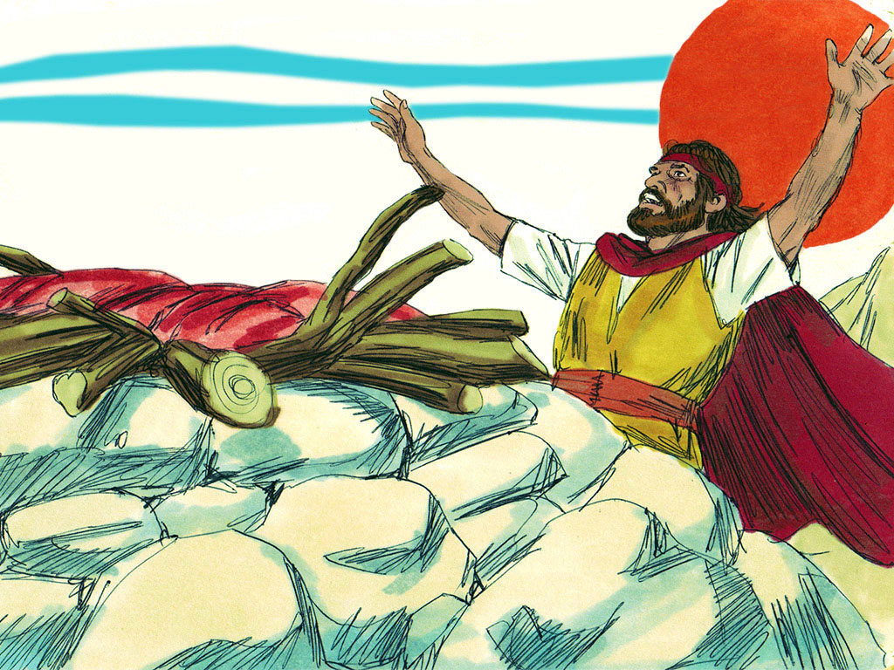

Thinking Question:

5. What happened after God sent the fire to burn up the sacrifice?
Lesson for Us
There is only
We can learn all about Him and how to serve Him from the Bible – His words to us!
GOD

