Lesson 10 – Elisha Helps the Woman of Shunem
True or False? Circle the right answer
1. One day, when the Shunammites son was out in the field with his father he became very ill. He went to his father and said, “My head! My head!”

True or False

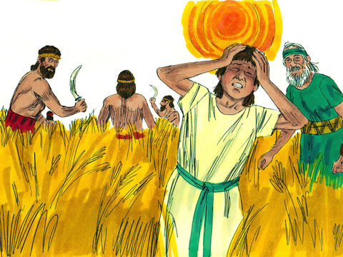
2. What happened to the Shunamite’s son?

What Happened First?
3. Number the circles from 1 to 6 to put the story in the right order

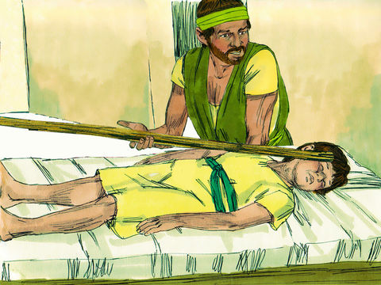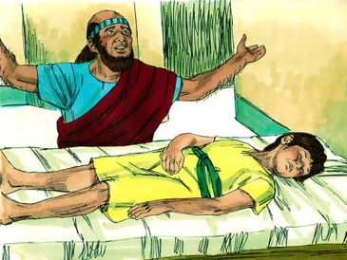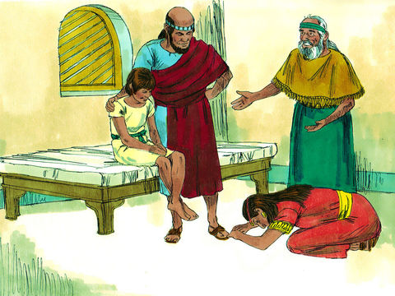
With her child alive, the Shunamite woman fell down at Elisha’s feet and thanked God.
Elisha came into the house and found the boy on his bed. He shut the door and prayed to God.
Gehazi went on ahead of Elisha and laid Elisha’s staff upon the boy but nothing happened.

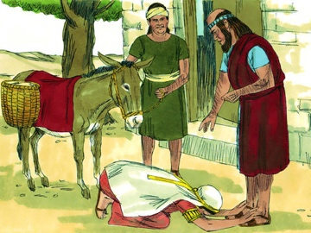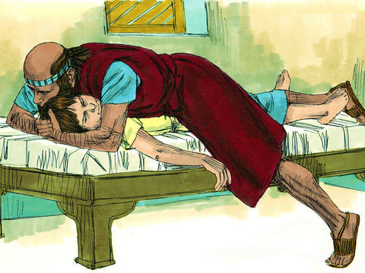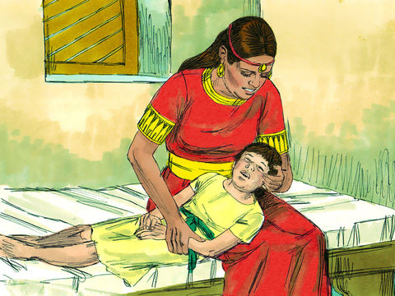
The Shunamite nursed her sick son on her lap until midday but he became worse and died.
Elisha lay on the child. The boy began to grow warm. He walked around the house and di it again. The boy sneezed 7 times! He was alive!
The Shunamite woman fell down before Elisha and caught hold of his feet. He knew she was worried about something.

Thinking Question:

4. Why did the Shunamite woman go to Elisha for help when her son died?

Circle the right answer to fill in the blank:
living / dead
4. Nothing is too hard for God. He can even raise the ______________________________. Jesus will do this work for God when he returns to the _________________________.”
earth / heavens

Lesson for Us

God answered the prayer of Elisha. He hears and answers the prayers of all those who believe and obey him. What are some things that you can pray to God for? Draw or write them in the box below.

