Circle the answer:

1. Elisha did not want to leave Elijah. Every time Elijah asked him to stay behind, he said:
- I will not leave thee
- I am going to miss you very much
- What am I going to do?
- The LORD be with you

Lesson 8 – Elijah and the Fiery Chariot
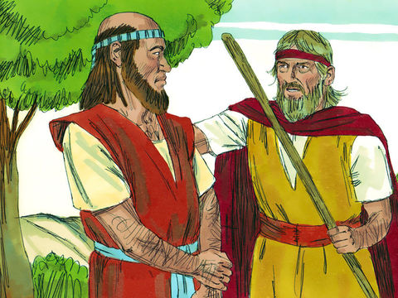
Fill in the blank: Circle the right answer to complete the sentences

2. Elijah and Elisha came to the River _________________________. Elijah took his ___________________ from off his shoulders. He _______________________ the water with it. The water divided and the two men were able to cross over on a path of ___________________________!

mantle / staff
Nile / Jordan

smiled at / hit

sticky mud / dry ground

True or False? Circle the right answer
True or False

3. Just before he departed, Elijah asked what he could do for Elisha. Elisha asked for a triple portion of Elijah’s spirit.

Thinking Question:

5. Tell what happened after Elijah and Elisha crossed the River Jordan?

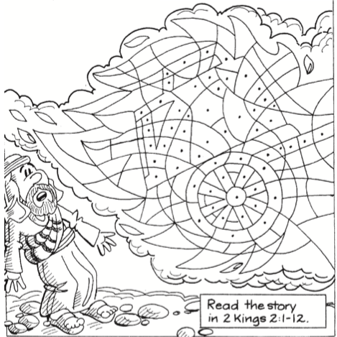
Color the boxes with the dots red and the boxes without dots yellow or orange
To receive the double portion of Elijah’s spirit, Elisha had to watch him be taken away. Colour the picture to see what separated the two men before Elijah went up in the whirlwind.

Fill in the Blank
7. When the sons of the prophets saw Elisha with Elijah’s cloak they said,

“The Spirit of doth rest on

Circle the answer:
6. When Elisha wanted to cross back across the River Jordan, he:
a) hit the water with his staff and it parted
b) made a raft and floated across
c)took Elijah’s cloak that had fallen on the ground and struck the water and it parted
d) swam across because it was a nice day

