Lesson 9 – The Kind Woman of Shunem
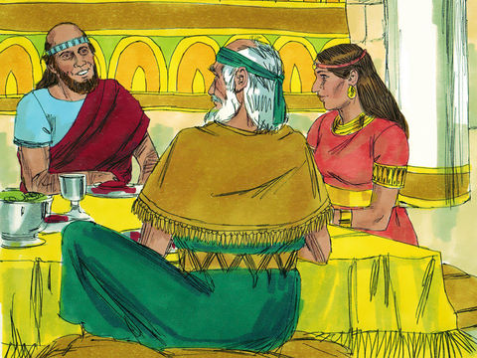
1. There was a kind lady who helped Elisha. What was the name of the town where she lived?

2. The kind lady of Shunem and her husband built a special little room for Elisha. Draw the 4 things that they put in the room for him.

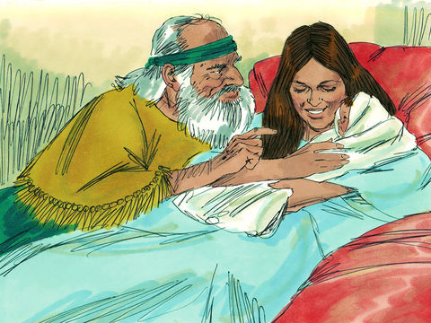
Circle the answer:

3. Because of her kindness, Elisha told the woman of Shunem that
- He would pay her to stay in the room
- He would make dinner for her and her husband
- God would bless her with a little baby boy
- He would mention her to the king

Lesson for Us

5. The lady of Shunem showed kindness to Elisha. We should always be kind and thoughtful to others. What are some things you can do that are kind and thoughtful? Write or draw your answer.

