Lesson 11 – Naaman the Syrian
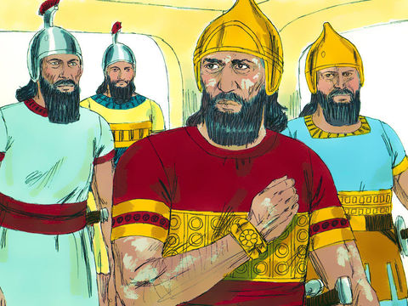
- Who was the captain of the army of the King of Assyria who had leprosy?

True or False? Circle the right answer
2. A little maid from Israel, who served Naaman’s wife, knew where Naaman could go to be cured of his leprosy.

True or False

4. Elisha told Naaman to:
- Offer a sacrifice on the top of Mt. Horeb and you will be clean.
- Go wash in one of the rivers of Damascus and you will be clean
- Go wash in the Jordan 7 times and your flesh will be healed and you will be clean.

(HINT – there are two right answers!)
Circle the answer:

3. When Elisha heard that the king of Israel was angry and would not help Naaman he said:
- “Good! Send him back to Assyria”
- “Send Naaman to me and he will find out that there is a prophet in Israel
- “We won’t help our enemies!”

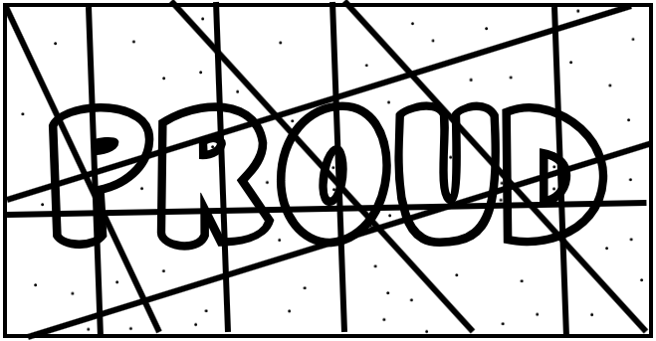
Colour Fun!

Colour the shapes with the dots blue and the shapes without dots red to find out why Naaman didn’t obey Elisha at first.

He was too ___________

Circle the right answer to finish the sentence:
Euphrates / Jordan
5. So Naaman went down to the river ____________________. He dipped himself _________ times in the river, just as _______________ had said. To his great joy his skin became __________________ again, soft and smooth like the skin of a ___________________. He was healed!
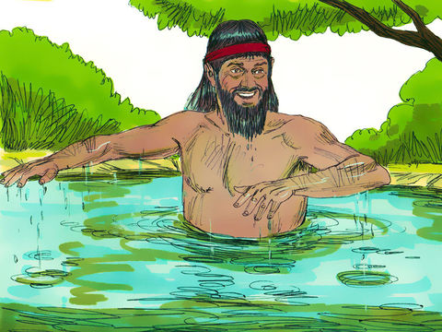
alligator / child
bumpy / clean
Elijah / Elisha
7 / 3
Thinking Question:

6. Why did Elisha refuse to take the presents from Naaman?
Lesson for Us

From this lesson we learn how important it is to OBEY!
Children are to obey their parents in the Lord. Draw a picture of you and your parents.

We must Obey:

- Right Away

- All the Way 💯%

- In a Happy Way

