Circle the answer:

1. God wanted Jonah to go to Nineveh because:
- He needed a vacation.
- He needed to warn the people that God was going to punish them for their wicked ways.
- He had family there that he hadn’t seen in a long time.
Lesson 12 – Jonah the Prophet
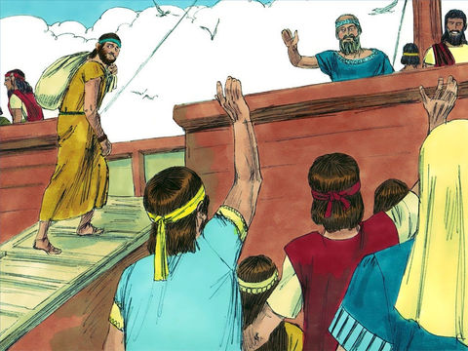

Fill in the blank by circling the right answer:
Ninevah / Rome
2. Jonah did not want to go to ____________________. He decided to run away, far across the sea, as far away as he could get from Nineveh. Then he would not have to do what _________________ told him. He went to __________________ and there he found a _______________ ready to sail to _______________________.
Nineveh / Tarshish
ship / kite
Jerusalem / Joppa
The King / God

True or False? Circle the right answer
3. Once the ship started on its journey a huge storm blew in. It was so bad that the sailors became very frightened

True or False

Finish the Picture
4. The sailors woke up Jonah and he told them what to do. Draw what happened next

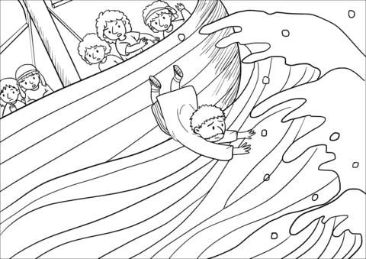
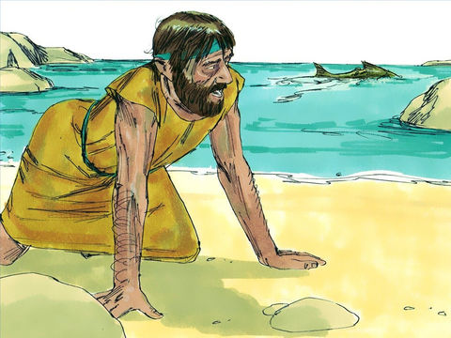
5. What did God send to swallow up Jonah?

Thinking Question:

5. What did the people of Nineveh do when they heard Jonah’s preaching? Did God destroy them as he said he would?

Lesson for Us

Print the first letter of the animal in the box to see the secret word.

from God.
We cannot

He can see us wherever we are.

