CSSA STAGE 3 INTERMEDIATE Handout #1 NAME ________________________________

Asa the King of Judah

Multiple Choice: (Circle ALL the Correct Answers)
1. Asa had peace because:
a) he had a mighty army b) he had so many friends
c) God gave him peace for destroying the idols d) he was afraid to fight

2. Asa fought with a king from Africa named:
a) Rory b) Zimgauwai c) Adam
d) Michael e) Zerah f) Heraz

3. The King from Africa could only fight one day because:
a) his soldiers were tired b) so many of his soldiers were killed
c) many of his soldiers deserted his army d) he ran out of money

4. Azariah, the son of Obed:
a) encouraged Asa to trust God b) became a false prophet
c) tried to kill Asa d) joined Zerah’s army

Short Answer Questions

5. What kind of king was Abijah (Asa’s dad)? _______________________________________

6. Was Asa the King of Israel or the King of Judah? __________________________________

7. What good things did Asa do when he became king? _______________________________

_________________________________________________________________________

8. What special thing did Asa do in his 15th year as king?

9. Who did Asa command the people of Judah to obey? ________________________________
True or False

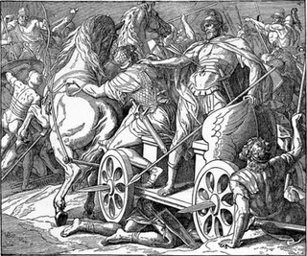
_____10. Asa gathered all the people from Judah and Benjamin to sacrifice to God in his 15th year as king.

_____11. We can help others to learn about God by reading our Bibles and talking to them about God.

_____12. Asa's Mother, Maacah, worshipped God and taught Asa to love God.

_____13. Baasha King of Israel attacked Judah during Asa's 36th year as king.

_____14. Asa turned to God for help to defeat Baasha King of Israel.

Lessons for Us

15. Hanani told Asa he was wrong to depend on help from Ben-Hadad. He should have asked God for help. Asa was angry and put Hanani in prison. What lesson can we learn from Asa's mistake? _________________________________________________________________________

_________________________________________________________________________

16. Asa commanded the people to obey God and remove the foreign altars. God gave Asa peace. What lesson can we learn from Asa's good example?

_________________________________________________________________________

_________________________________________________________________________

17. Asa got a disease in his feet. He asked help from the doctors and not from God. He died two years later. What lesson can we learn from Asa's mistake?

________________________________________________________________________

________________________________________________________________________

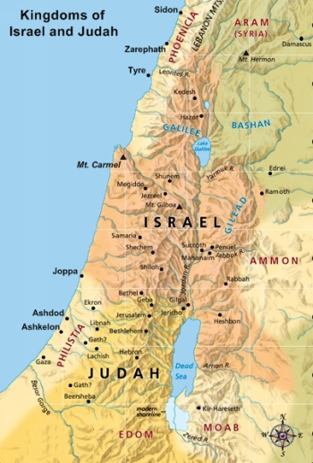
Matching (Draw lines to connect)

Zerah King of Judah

Ben-Hadad King of Syria
Asa Mother of Asa
Jehoshaphat Son of Obed
Azariah King of Israel
Maacah King from Africa
Hanani Son of Asa

B aasha Prophet put in prison

