CSSA STAGE 3 INTERMEDIATE Handout #2 NAME ___________________________________

Jehoshaphat King of Judah

Fill in the Blank

1. When King Asa died, his son, __________________ became the next king of Judah.

2. Jehoshaphat did not ask for help from _________________________.

3. Jehoshaphat asked for help from the true _________________________.

4. In Jehoshaphat’s third year as king, he sent __________________ and _________________ to teach the law of God to the people.

5. Jehoshaphat made a big mistake by making a ___________________ _________________ with King Ahab of Israel.

The Marriage Agreement between Israel & Judah
Judah

Israel

6. King Ahab married __________________ King Jehoshaphat and his wife

7. Athaliah of Israel married a boy from Judah _________________________.

True or False
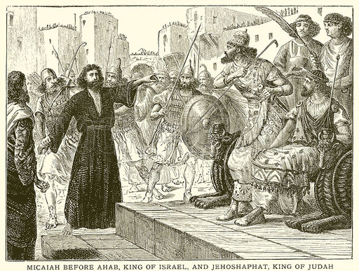
8. _____ Now that King Ahab and King Jehoshaphat were related by the marriage of their children, King Ahab asked King Jehoshaphat to help him attack the Syrians.

9. _____ King Jehoshaphat agreed to join with King Ahab and attack the Syrians, but first wanted to ask Yahweh to guide them.
10. _____ King Ahab had 400 prophets of God.

11. _____ Micaiah, the true prophet of God, told the kings not to fight.

Thought Questions
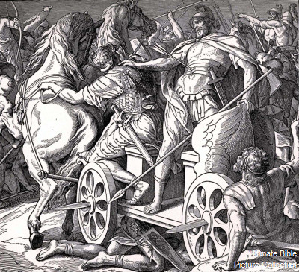
12. Why do you think King Ahab had King Jehoshaphat wear his royal clothes, but did not wear any himself? ___________________________________________

___________________________________________

13. Why do you think the King of Syria told his soldiers to only fight with King Ahab? ___________________________________________

___________________________________________

14. Do you think it was just “chance” that a Syrian soldier happened to shoot an arrow and kill King Ahab? Why?_____________________________________

___________________________________________________________________________

Multiple Choice: Circle ALL the Correct Answers!

15. When some people from Moab, Ammon and Edom gathered to fight against King
Jehoshaphat, he asked help from:
a) Baal b) Yahweh c) his mom

16. God responded by:
a) sending a plague b) causing the enemy to kill each other
c) making the enemy army run away d) hiding King Jehoshaphat’s army

17. King Jehoram (Jehoshaphat’s son) became the next king of Judah. King Jehoram was:
a) good like his father b) bad because he was married to Ahab’s daughter
c) 40 when he became king d) a true worshipper of Yahweh

Who’s Who? (Match the following by drawing lines)

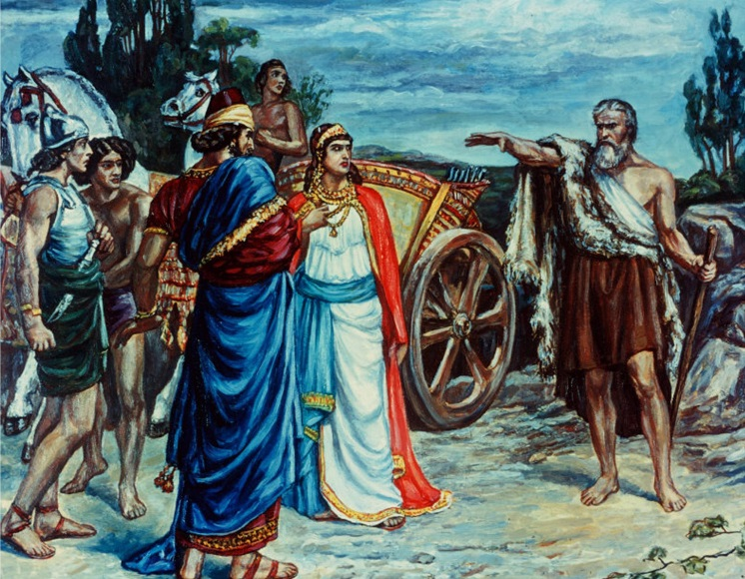
King Jehoshaphat false prophet

King Ahab true prophet of God

Jezebel married to Ahab

Jehoram married to Athaliah

Athaliah killed with an arrow

Micaiah daughter of Jezebel

Zedekiah good king of Judah

Jehu true prophet of God

